'o'r'd

x

(s4teyg = OL)

0!

l. 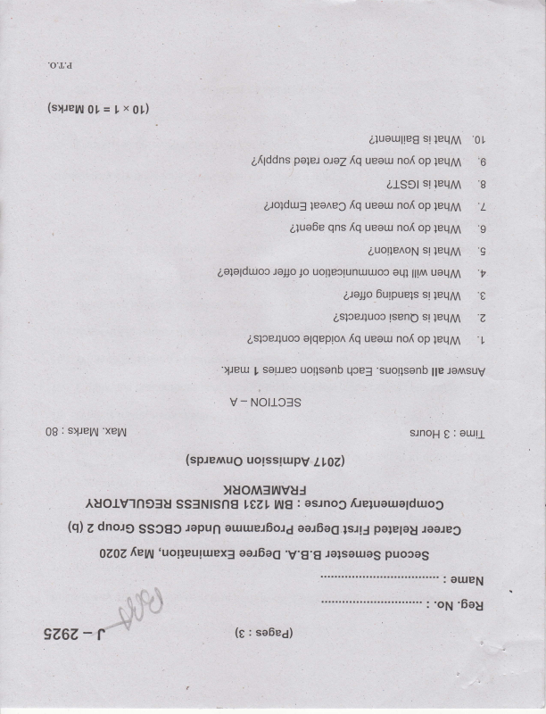

leqM s! Lluol.xlte8 '0t

}eLlM op no{ ueeur oJeZIq po}el a{lddns '6

s! alsct leqM '8

]eqM op no[ ueou {q qns alue6e 'g

leqM s! auotle^oN 'g

uallM lll^ orll uotleclunuuoc Jo Jol]o 6e1alduoc '?

0 leqM s! Oulpuels Uel1c

LslceJluoc sl tseno leqM 'z

}eqM op no{ ueou {q olqeplon aslcerluoc 'l

"Ueu qcef uorlsanb saueo I 'suollsenb suv Jol llp

Not133S - v

0B suey\l : 'xey\

oull : e sJnoH

uotsslutpv (sp.rernug LIOZ)

yuoMf ruvuJfteluaue;duog osrnog : 6E LtZ, SS3NISnA AUOIVI6CIU roareo polelag lslJ eal6o6 euruet6ol6 rspun SSOgg Zdno.rg @)  OZOZ puooas ralsauas 'V.g.g eel6og 'uot;euguex3 fieru

OUIEN :

i.::

l-"'i!.'|,'I

. ii} I' i.l !

r - 9267, sa6e6) (g:  ",,,;4.*t "'

'6eg op

=

r 9Z6Z-

Z

'ecueldecce e uleldx3 or.ll letluosso sluotuoto ]o

'92

ptlen

'slce4uoc pue olqepton qsrn6ullsl6 laq uool pton

'vz

lceJluoc

'tz

'slceJluoo uoal sluorueelbe qsrn6unsl6 loq pue

(s1.reyy9[=Zxg)

, 'suollsenb SuV JoA fiue xgs 'slJetu qce= uollsenb souJec 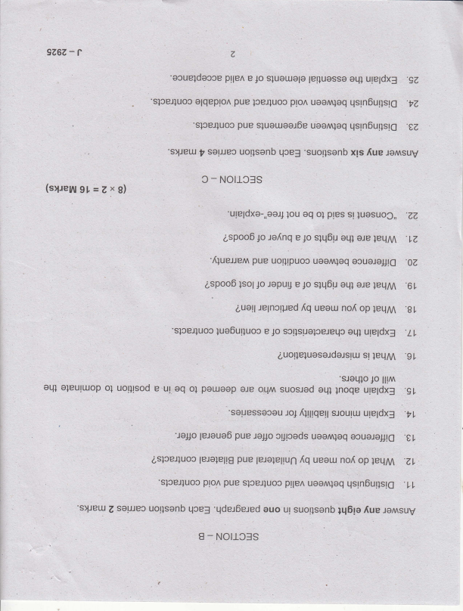

S Notl3f - 3

'ugeldxo-,,oaJ,lou st ples ol oq luosuoC,, -ZZ aspooolo ole oLl] s1q6lr 1o e .re[nq ]eLlM .lZ 'fiueJJen oouoloJ16 loq .OZ uool uotlrpuoc pue

leqM are aql s1q6u 1o e ropuu Jo lsol aspooo .6 L

auall op nof ueeur {q lelncrped ]eqM .g t

'sloeJluoc uleldx3 otll sctlsuoloeJeLp Jo e lue6ulluoc -Ll ]eqM sl euo[e]uose;delslr.r.r 'gt

'sJoLllo ll!^ Jo

suosred oll^ ore por.uoop ol oq ur e uotltsod ol oleuttuop oql rnoqr'rllr,jiiJ eq1 '91

;eleue6 'tl,

'Jo#o ocuoleJJt6 uoomloq cgrCeds JolJo pue

lerolellg aslceJluoo ^q op no{ ueau }eqM .ZL

pue

leJalellun

'slceJluoc uoo^ plle^ sloeJluoo qsln6urlsr6 loq .LL pue plol

'slJeu qce3 uollsanb solJJec Z auo

'qdet6e.red suv Joi {up 1q6le suotlsanb ul

NO|ICSS - I

r 9267,- 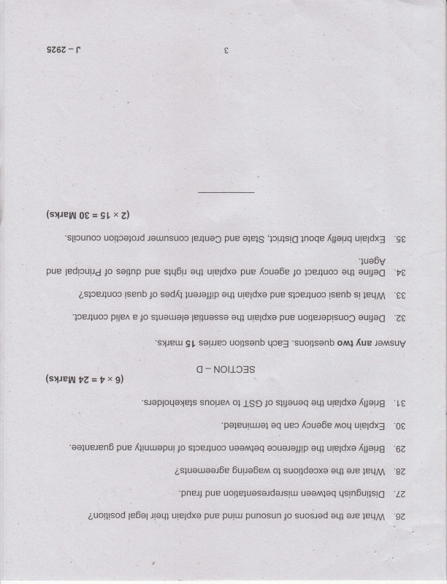

e

(sryeyy0t=9txZl

'slpunoc lounsuoc olels pue

uoqcelold

le4uoC 'lcpls'l6 ]noqe uteldx3 {peuq 'g0 lueOy

pue our}og ol-l} }ceJ}uoc 1o {cue6e pue ule;dxe oql slq6u pue soqnp 1o ;edrcui.r4

,t,

}eqM sl lsenb sloel}uoc pue uleldxo eq1 luolo;Jtp sed{} p lsenb aslceJluoo  e0

'lcelluoo ou1106 uotleJoptsuoC pue ureldxe oLll  'zt,

e pllen

?Z=?xg)

(s1.re111

lelluasso sluorlolo Io

gI 'slJetu qcef uorlsenb sorJJeo ornl 'suorlsenb SUV JoA fiue

Notl-css - o

oI snouen sJoploqa)els ule;dxe eLll sl4ouoq Jo ISe fpeug '10 'paleulruJal ure;dx3 anoq Icue0e uec '00

aq

'oalueJen6 {geug ule;dxe oql muaJoJ1p loq uao^ slceJluoc firuueputJo '67 pue

1eqry1 ere sLll suorldecxo o1 Ouue6enn asluouaoj6e ,g7 '

leq '/Z

'pnp4 qsrn6ullsl6

: uaan uo!]elueselde;sltu pue

punosun pulll pue ure;dxe 1e6elrletll auolllsod 'gZ

leqM ale aql suod1ed Jo

,i

J -2857

Second Semester B,A-/B.Sc./B.ComJBBA/BCA/BSWBMSIB.Voc. Degree Eiamination, May 2020

Career Rdlated First Degree Programme Under CBCSS

' Group 2(b)

, Language Course ll

1271.41EN211 ; WRITING AND PRESENTATION 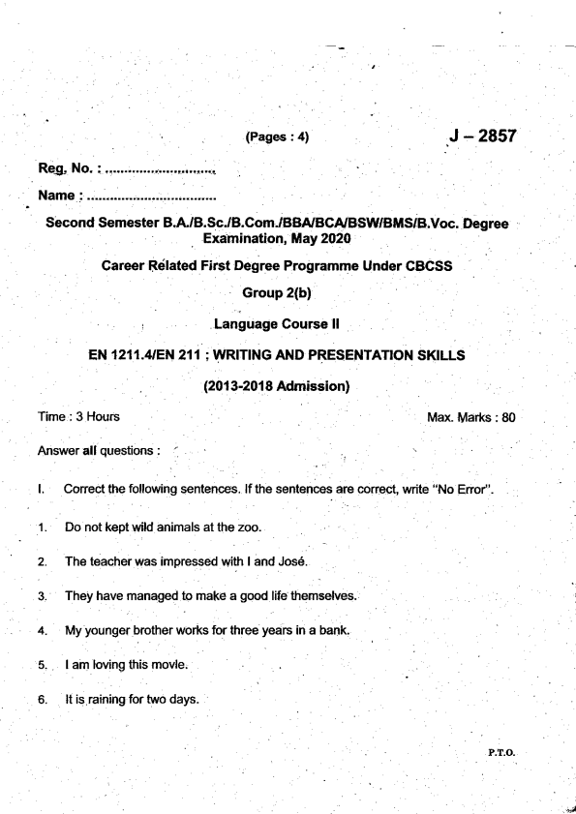

. (2013-2018 Adrnission)

t.

't.

2.

J.

4.

5.

6.

.

SKILLS

Max. Marks : 80 P.T_O-

It slipped the mind. 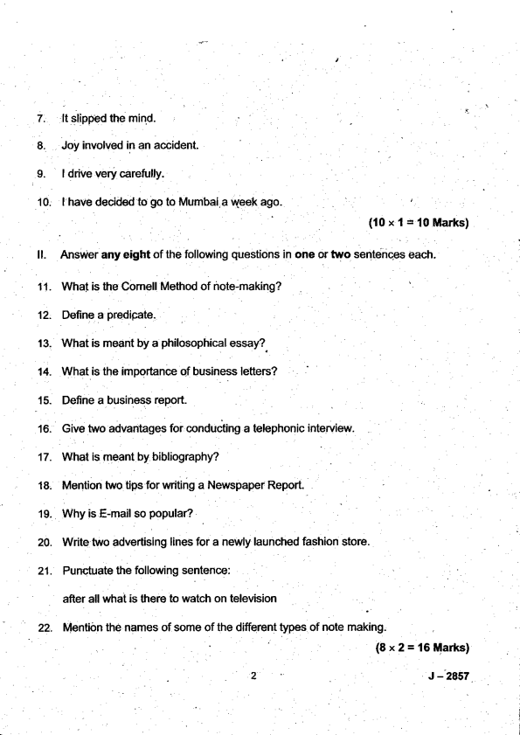

(10x1:'t0Marks)

ll. Answer any eight of the following questions in one or two sentences each. 11. What is ttre Comell Method of note-making?

12. Define a predipate.

13. What is meant by a philosophical essay?

14. What is the importance of business letters?

15. Define a business report.

16. Give two advantages for conducting a telephonic interview

17. What is meant by bibliography?

18. Mention two tips for writing a Newspaper Report.

19. why is E-mail so popular?

20. Write two advertising lines for a newly launched fashion store.

21. Punctuate the following sentence:

after all what is there to watch on television

' 22. Mention the names of some of the different types of note making. (8x2=16Marks)

J - 2457

lll. Answer any six directed.

23. Write a letter to the Librarian for reissuing your Library card.

Construct a dialogue on the following topic in about 80 words. 24.

You are at a Mobile Phone. You ask the shopkeeper about the phones.

latest mobile

25. Prepare a,report on Diseases'.

an awareness programme mnducted towards 'Lifestyle

26. Prepare a functional cuniculum vitae highlighting.your skills and experience. 27. What are the characteristic features of E-mails? 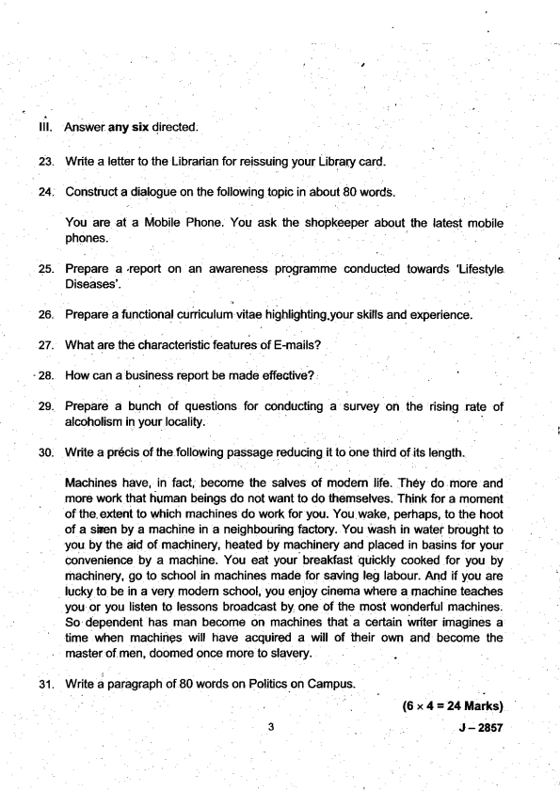

- 28. How can a business report be made effective?

29. Prepare a bunch of questions for conducting a survey on the rising rate of

30. Write a pr6cis of the following passage reducing it to one third of its length.

Machines have,.in fact, .become the salves of modem life. They do.more and . more work that human beings do not want to do themselves. Think for a moment of the. extent to which machines do work for you. You wake, perhaps, to the hoot of a sken by a machine in a neighbouring factory. You ivash in watei brought to you by the aid of machinery, heated by machinery and placed in basins for your convenience by a machine. You eat your breaKast quickly cooked for you by machinery, go to school in machines made for saving leg labour. And if you are lucky to be in a very modem school, you enjoy cinema where a machine teaches you or you listen to lessons broadcast by one of the most wonderful machines. So dependent has man bemme on machines that a certain w ter imagines a

' time when machines will have acquired a will of their own and become the master of men, doomed once more to slavery.

3l. Write a paragraph of 80 words on Politics.on Campus.

(6x4=24Marks)

,

3

J - 2AS7

Answer any two . of the following.

Write an essay on any one of the Jollowing in about two to three pages. 32.

(a) Reading as a habit.

(b) The drawbacks of social media.

(c) Universal Literacy.

33. Write a project report on any one of the following topics: (a) E-Leaming . .

(b) Rise of rural lndia,

(c) Decline in mortality.

u.

Create content for 15-20 slides on any one Presentation.

(a) The importance of communication. (b) The perils of smartphones.

(c) Youth and Social Media.

of the following Power Point

Write an essay elaborating the various methods of data collection. 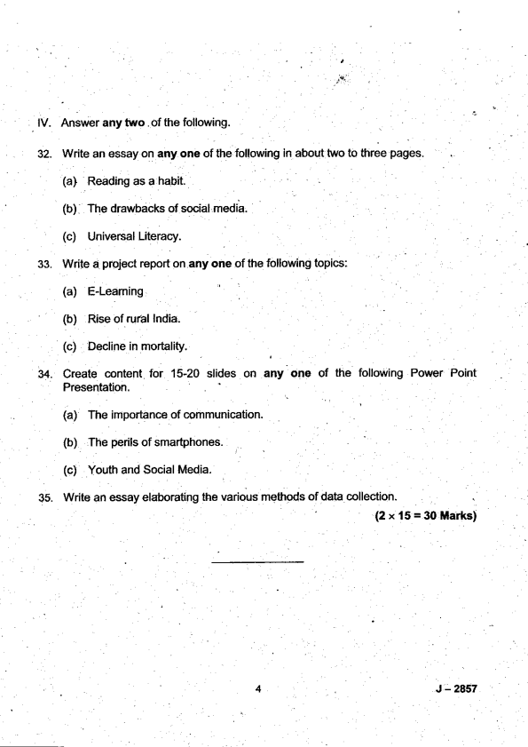

35.

' (2* 15=30 Marks)

J 4 - 2a57

(Pases:3) J -2922 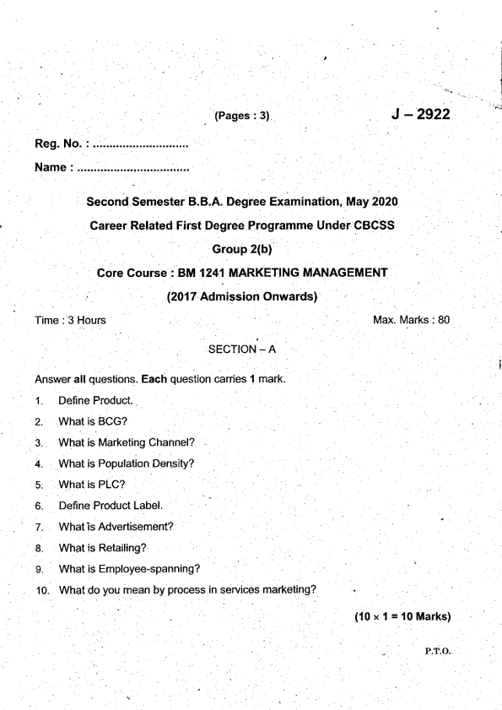

l

Name : .............................,,,..

,]

Second Semester B.B.A. Degree Examination, May 2O2O

Gareer Related First Degree Programme Under CBCSS

. Group 2(b)

Core Course i BM 1241 MARKETING MANAGEMENT

(2017 Admission Onwards)

I rme : :l Hours Max. Marks : 80 SECTION - A

Answer all questions. Each question carries 1 mark.

1. Derine Product..

2. What is BCG?

3. What is Marketing Channel?

4. What is Population Density?

5. What is PLC?

6. Define Product Label.

7. What is Advertisement?

8. What is Retailing?

9. What is Employee-spanning?

10. What do you mean by process in services marketing?

(10x1=10Marks)

_ P.T.O.

SECTION _ B, 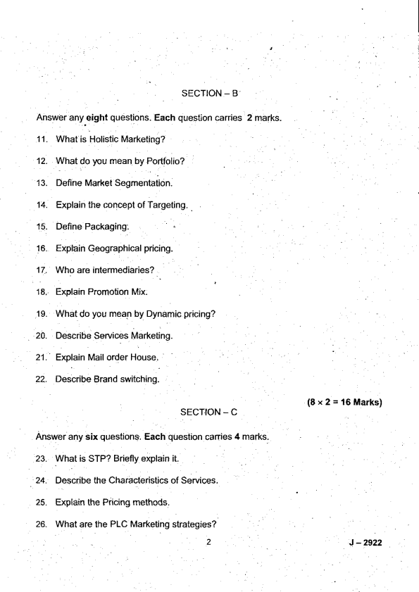

Answer any eight questions. Each question carries 1 1. What is Holistic Marketing?

12. What do )rou mean by Portfolio?

13. Define Market Segmentation

14. Explain the concept of Targeting. .

15. Define Packaging:

16. Explain Geographical pricinq.

17. Who are intermediaries?

18. Explain Promotion Mix.

19. What do you mean by Dynamic pricing? 20. Describe Services Marketing.

21. Explain Mail order House.

22. Describe Brand switching.

2 marks-

(8x2='16Marks)

J - 2922

(6x4=24Marks) 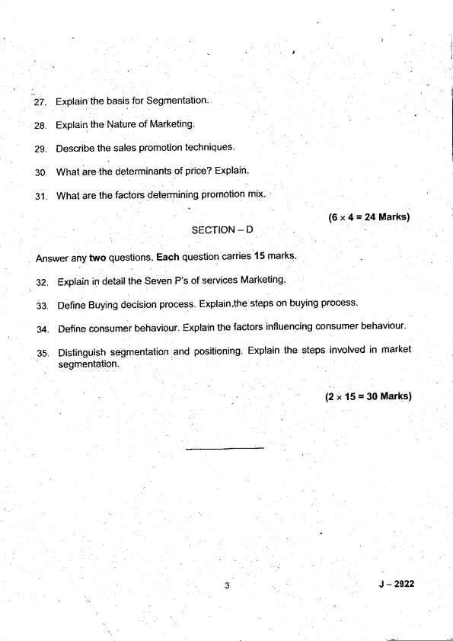

SECTION _ D

Answer any two questions. Each question carries 15 marks'

, 32. Explain in detail the Seven P's of seryices Marketing.

33. Define Buying decision process. Explain.the steps on buying process' 34. Define consumer behaviour. Explain the factors influencing consumer behaviour'

35. Distinguish segmentation .and positioning. Explain the steps involved in market segmentation.

(2 " 15 = 30 Marks)

J - 2922

Reg. No. i ..... *.... - . . . , . . . . . . . . . . . . Name

(Pages : 3)

J- 2923

Seccind Semester B,B.A Degree Examination, May 2020 Career Related First Degree Programme Under CBCSS Group 2(b)

Core Course : BM 1242 HUMAN RESOURCE MANAGEMENT (2017 Admission Onwafds)

Time : 3 Hours

t.

1.

2.

3.

4.

5.

6.

7.

9.

10.

SECTION - A 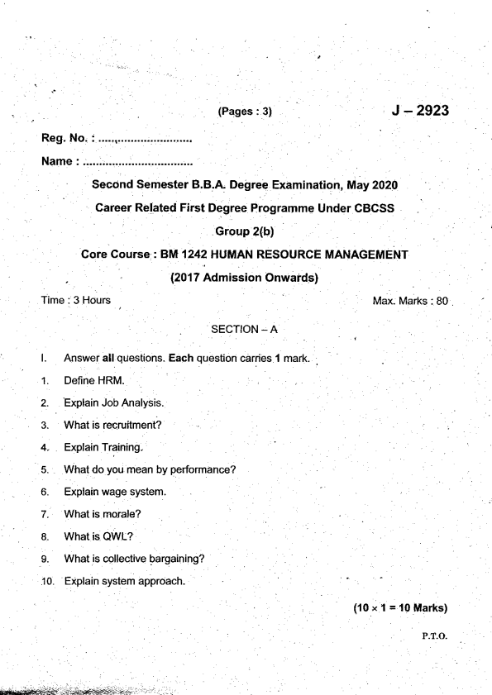

mark.

Max. Marks : 80

(10 x I = l0ltllarks) P-T-O-

(8x2=16Marks) J - 2923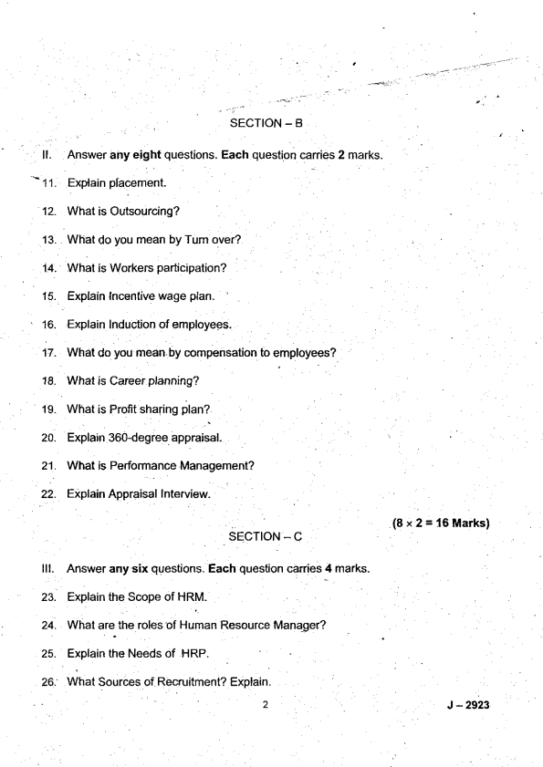

Briefly describe the Types of Management Development. Explain the Process of Performance Appraisal.

Discuss workers participation in Management.

Differentlate job descdption and Job Ddsign.

What are the types of interview'? Explain briefly.

31.

SECTION _ D

tv.

Answer any two questions. Each question carries 15 marks. .

(6x4=24Marks)

What do you.mean by Pertormance Appraisal? Explain its nature and objectives. 32. 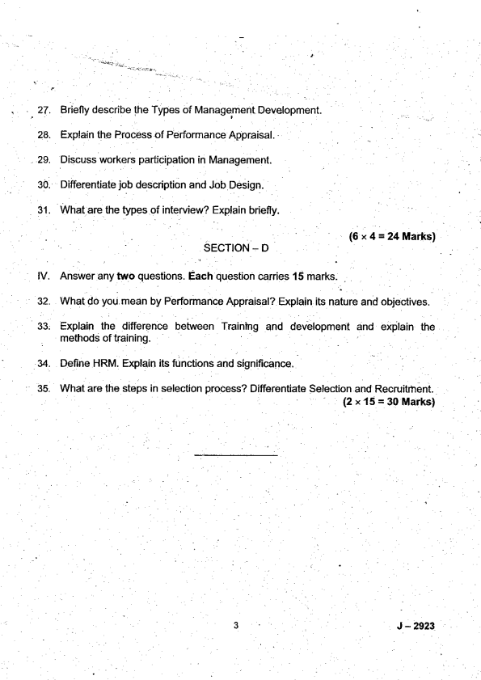

Explaan the difference between Trainlng and devebpment and explain the methods of training

u.

Derine HRM. Explain its functions and significance.

What are the steps in selection process? Differentiate Selection and Recruitrhent.

35_

(2 x 15 = 30 Marks)

J - 2923

(Pases:3) J-2924 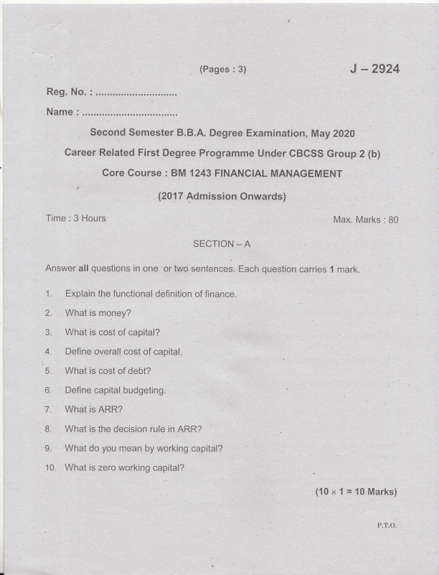

Reg. No. :

Name :

Second Semester B.B,A. Degree. Examination, May Z02O

career Related First Degree Progrimme Under cBCsS Group 2 (b)

'/

tl (2017 Admission Onwards)

Time : 3 Hours Max. Marks : B0 SECTION _ A

Ahswer: all questions in one or two sentences. Each question carries 1 mark. 1. Explain the functional definition of finance.

4. Define overall cost of capital.

:

5. What is cost of debt? l

1^ 7. What is ARR?

L What do you mean by working capital?

10. What is zero working capital?

(10 x 1 = 10 Marks)

P.T,O.

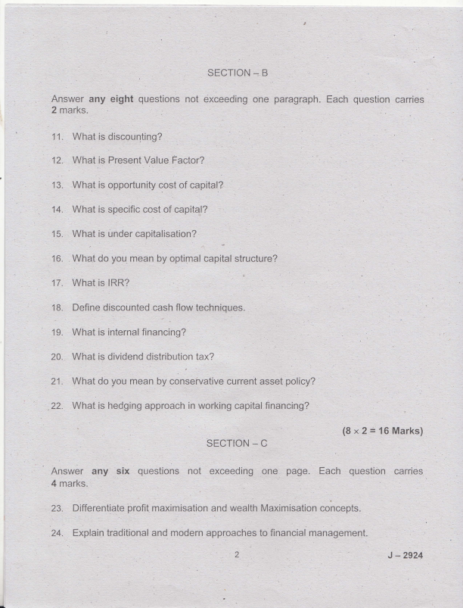

25. 

26. A ltd issued '10000 15% debentures of Rs. 100 each at a discount of Rs.S%.The debentures are irredeemable. Cost of issue is 2o/o and rate of tax 1s 5A%. Calculate the cost of capital before and after tax.

27. Explain the characteristics of optimum capital structure.

i

28. Explain the nature of capital budgeting.

30. Explain the assumptions of Walters model dividend theory.

31, Explain the motives for holding cash.

(6 x4=24Marks)

SECTION. D

Answer iny two questions not exceeding four pages. Each question carries 15 marks.

32. What do you mean by receivables? Explain the benefits associated with receivables and factors affecting the size of receivables:

Discuss different types of capital budgeting techniques.

, 'o' 35.

Explain the factois determines the dividend policy.

Explain the factors determine working capital.

(2 x 15 = 30 Marks)

J -2924

t

9- -Neithor my 'sentence). father not my brother are @ming for the. programme.

(Conect the

10. lcanrt , ' with this anymore! (Use tne-applopriate phrasal verb which means 'tolarate'. 

(10x1=l0Marks)

Answer any eight of the

. 11. Give the antonym of two of the.fonowing $d,tdq

(a) soff

'(a) How a pW thatpu

(b) Soa shame that he

13. Make sentences of your own with any two of the phrasal verbs :

(d) gave up

Fill in the blank with the conect Wh word :

{a) ---- is the best btlrger in this re.BtaUnant?

(b) I have not yet found fle girl

.i I J-.?521i

18. (a) {b)

Th€re are many types of rlsfres at the cold storage now.

19. (a) Ths dryrad,hg of the envir.onrnent u,ill leadlo our erd- (b) i,lany animals th€se days face axreflsbr,.

. lll. . Answer any slx of the follot ring qusstions : 

23. Match the pads in column A with that of collml I

(a) Practjoe the.-song we[ (D thal we may gain knowledge (b): Here comes n6ne other '(it) and a,lyricist.

(c) The boys care for neither , ( i) lest y6u forgret your lyncs.

' (d) Heis both a singer (iv) than the star singer!

(e) We.read (v) rnoney nor fame.

24. Fill.in the btanks with the conec{ oplion :

(a) I had asked.yog to 1--- immediately, hadn't l? (irrite menvrito to

. me)

(b) The inflation will- people badly. (atrect/efiec1)

(cl) He ms .:.---:- trom wort for. not doing his work well' (aid off/layed

25. Spot the 6nor, underline the' wrong phrase ard coned the sentences : I

(a) They do not stop lheir protest unless Uieir.pay is hiked.

(b) This shirt, so expensivei is too tight fpJ ms to w@r.

(c) She is absent orvning to her ill.

27. 

B: Yes

sure thal

29-

animal's, and

(b)

(c)

t

(d)

w.ortd, whicft

-'

(d) What do you rnean by halo? . 

- (aI

J -21;27

meaning to

(e) Why was he acc{sed of being a politician? (f) What does tuming'over in his rnind' mean?

(0 The Alpsare the Mountains in Europe. (g) This exam is.

e)demal examiner your'exam has anived--

(h)

The @!se is big :--------1- tor all of us to live in.

(i)

It was - evening when we reached the statioo (laternate) 0)

(k) He spoke (t)

his flrst bmk.

tired, u,e Uecided to lunch before going out. (being/to be)

(m)

My dog likes

cats. (to cias€/of chasing).

(n) ln spite of

(o) What do you plan

well, she was still tired; (having slepUsleeping)

her for her wedding? (to give/giving).

, (15x1=15ltarks)

GROUP B

Read the foflolr/ing passag€ and answer the questions below : 

34.

Qnce wfien I was six years old I saw a magnificent picture in a booft, called True Storie.s from l,lat re, about the pdmeval forel lt was a piciure of a boa consgictor in the ac{ of swallowing an animal. Here is a copy d the drawing. ln the book it said: 'Boa consMctors $/allow th€ir prey whole, without chewing it. Afler that they are not able to move, and they sleep through the six months that they need for digestion." I pondered deeply, [l€n, over the advenhrres of.the jungle. And affer sorne work with a colored pencil I succeeded in making my first drawing- My Drawing Number One. I shorved my masterpiecd to the grown-ups, anO aJked them whethbr the draw,ing. tbhFned them. But lh6y answered: iFrighten? Why should any onb ue fiighb@.by a hat?" i,ly drawing was not a pictw6 of a hat. It was a pk uIB of a boa Ss&ictor digegting an €lpphant But iince &e grown ups were not abb to un@r:tand.it, !made another drawing: I drew the inside of a Doa constriclo( so thd ttlB gronvn-ups could see it ctearty, They always need to have things explained.

l 

(a) What do You mean bY'magnifcent?

L (i). larsq (ii) exbeme! ireautitul maSrrifyns' (iv) tpnq of tle ahve :

(iiu magrrifying'

: , ' (b) What does 'pondered' nqan? ..

(i) to wander (iD like a Psd

(iii)lll, to Iuurll(qo{]ut thhk about (iv) uv, non€ rrvrr!ofthe vr {E aboven es

. (c) what is the meaning of 'disheartened?

fi) (benefited (ii) disptuitcd disptuit€d

' :' (iii) helped. ('9 su9pott€d .

(d) Which is the 'magnificent' picture mefll'tond?

I (e)l wtrat is a goa coGstrictor? :' '

'-,

I . (0 what was his first picfirre ofi

10- J.N'21

(i) to cany 

(lll) llcad

(m) ! rho is lhe nanator?

(n) . Give a suitable title for this passage. OR

(c)

(e)

(0

(s)

J - 2521

Time : 3 Hours

SECTION _ A

' J -2921 Max. Marks : 80

Answer.all questions in one ortwo sentences. Each question caries 1 mark. 1. What you mean by intemet? 

2. Expand HTML.

3. Expand C2C.

4. What is intemet shopping?

5 What is flowchart?

6. What is digital signaiure?

7. What is E business?

. .8- Expand lSP.

P.T,O.

9. What is firewall?' 

10. What you mean by cybercrimes?

_ (10 x 1 = Io:Marks) .

SECTION - B

Answer any eight questions not exceeding one paragraph. Each question canies 2 marks.

'l 1. What is search engine optimisation?

'12. Differentiate website and webpage

13. Define VVWW.

14. Deline E-Commerce.

15. Define encryption.

16. Who are certificate authorities?

17. ' Explain cheque transaction protocol used in E-commerce.

18. Define electronic payment system.

19. Deline e- business application

20. Define decryption of data.

21. What you mean by e-cash?

22. Write any t\ o examples of antivirus softwares.

(8x2=16Marks)

2 J -2921

SECTION - C 

Answer any six guestions not exceeding one paragraph. Each questions canies 4 marks.

23. Explain the advantages of E-Commerce.

24. Explain the operations of E-Commerce.

25. Briefly explain lhe advantages of.B2B.

26. Explain the various types of advertising on the intemet.

27. Describe the benefits of electrdnic payment sysiem.

28. Explain the behefits of firewall,

29. Explain the advantages of website. l

30.. Describe the advantages of debit card. '

31. Explain the public policy issues in e-commerce.

(6x4=24Marks)

SECTION - D

Answer any two questions not exceeding four pages. Each question canies 15 marks.

(2 x 15 = 30 Marks)

J - 2921

(Pases:3) M - 2688 

Reg. No. : .............................

Name : ..............

Second Semester B.B.A. Degree Examination, December 2021. Career Related First Degree Programme under CBCSS

Group 2(b)

Foundation Course

BM 1221- E-COMMERCE AND CYBER LAWS

(20'17 -2019 Admission)

Time : 3 Hours Max. l\4arks : 80

SECTION _ A

l. Answer all questions in one or two sentences. Each questions carries 1 mark 1. What is meant by internet protocol?

2. Expand WWW.

3. What is meant by E-Commerce?

4. What is meant by C2B?

5. What is internet banking?

6. What is E-Cash?

7. What you mean by website?

8. What is date encryption?

P.T.O.

9. Expand VIRUS. 

10. Who invented Hypertext Editor?

(10x1=10Marks)

SECTION _ B

Il. Answer any eight questions not exceeding one paragraph. Each questions carries 2 marks

'l 1. Differentiate web browser and webpage.

12. Define search engine?

13 Define electronic mail.

14. What is meant by social media?

15. Define electronic fund transfer.

16. Define cyber law.

17. What you mean by cyber security?

18. Define lPR.

19. Define cybercrime.

20. Define firewall.

21. Define antivirus.

22. Whatyou mean by antivirus software?

(8x2=16Marks)

SECTION _ C

lll. Answer any six questions not exceeding one page. Each questions carries 4 marks.

23. Explain the limitations of E- Commerce?

24. Discuss the functions of E-Commerce.

25. Explain the various types of web advertising fo'rmats.

M - 2688

26. List out the limitations of Traditional Payment System. 

27. Explain in detail about credit card based electronic payment system, 28. Descflbe various types of virus.

29. Describe the advanlages of credil card.

30. Explain the limitations of EFT.

31. Differentiate debit card and credit card.

(6x4=24Marks)

SECTION - D

lV. Answer any two questions not exceeding four pages. Each question carries '15 marks.

32. Explaln the various ways to make a website attractive.

33. Define E-Commerce. What are the advantages and disadvantages of E-Commerce?

34. What types of electronic payment system are required in E-Commerce? 35. What is e-business and explain the various components of e-business? (2 x 15 = 30 Marks)

M - 2688

(Pages : 3) M - 2691

Reg. No. :

Name :

Second Semester B.B.A. Degree Examination, December 2021 Career Related First Degree Programme under CBCSS

Group 2(b) Core Course

BM 1243: FINANCIAL MANAGEMENT

(2017-2019 Admission)

Time : 3 Hours

PART _ A

Max. Marks : 80

l. Answer all questions in one or two sentences. Each question carries 'l mark. 1. Why is finance remarked as life blood of business? 

2. How finance is different from account?

3. What is the operational meaning of cost of capital?

4. What do you understand by cost of equity?

5. What do you mean by cost of preference shares?

6. What is NPV?

7. What is profitability index?

8. What is the decision rule in NPV?

P.T.O.

9. What is gross working capital? 

10. What are cuffent assets?

(10x1=10Marks)

PART - B

ll. Answer any eight questions not exceeding one paragraph. Each question carries 2 marks.

11. Define time value of money.

12. What do you mean by annuity?

'13. Define over capitalisation.

14. What do you mean by capital structure? '

15. What is realised yield method?

16. What do you mean by book value weights?

17. What is the decision rule in IRR?

18. What is discounted payback period method?

19. What do you mean by dividend decisions?

20. What is retained earnings?

21. What is net working capital?

22. Explain operating cycle concepl.

{8x2=16Marks)

M - 2691

PART _ C 

lll. Answer any six questions not exceeding one page. Each question carries 4 marks.

23. Explain the valuation concepts.

24. Explain the major classifications of risks.

25. X ltd has issued 20000 equity shares of Rs.'100 each as fully paid. The present market price of these shares is Rs.160 per share. The company has paid a dividend of Rs. 1O/share. Find out cost of equity capital.

26. Explain lhe objectives of optimum capilal structure.

27. Explain the assumptions in net operating income approach.

28. Explain various traditional capital budgeting techniques.

29. A project with an outlay of Rs.'12,000, Rs.2,000, Rs.3,000,Rs.4,000,Rs.6,000 respectively in first, second, third and fourth year. Calculate payback period.

30. Explain various types of dividend policy.

31. Define the kinds of working capital.

(6x4=24Marks)

PART - D

lV. Answer any two questions not exceeding four page. Each question carries 15 marks.

32. Explain the functions of financial manager.

33. Discuss the factors determine capital structure.

34. Explain the dividend theories.

35. Explain capital structure theories.

(2 x 15 = 30 Marks)

M - 2591

(Pages : 3) M - 2690 

Reg. No. :

' Name:

Second Semester B.B.A. Degree Examination, December 202'1. Career Related First Degree Programme under CBCSS

Group 2(b) - Core Course

BM 1242- HUMAN RESOURCE MANAGEMENT

(2017 - 2019 Admission)

Time : 3 Hours Max. Marks : 80 SECTION - A

Answer all questions. Each question carries 1 mark.

1. What is personal Management?

2. What is HRP?

3. What do you mean by Selection?

4. What do you mean by Employee Development?

5. What do you mean by Compensation?

6. What is 'Wage'?

7. Explain Fringe benefit.

8. What is Team building?

9. What is Employee absenteeism?

10. Explain Quality Circle.

(10x1=10Marks)

P.T.O.

SECTION _ B 

ll. Answer any eight questions. Each question carries 2 marks. 'l 1. What is Simulated training?

12. What is meant by BARS?

13. What is Job Rotation?

14. What do you mean by 'On the Job Training'? 15. Define Performance Analysis.

16. What is Work sampling Technique?

'17. What is Expectancy chart?

'18. What do you mean by lnternship?

'19. What is Succession planning?

20. What do you mean by lnduction?

21. What you mean by Job analysis?

22. What is Collective bargaining?

SECTION _ C

lll. Answer any six questions. Each question carries 4 marks. 23. Explain the Significance of HRM.

24. Briefly detail the functions of HRM.

25. Describe the lmpodance of HRP.

(8x2=16Marks) M - 2690

26. What are the objectives of Management Development? 

27. B;iefly explain the Methods of Training.

28. Differentiate Job analysis and Job description.

29. Explain various Compensation to employees.

30. Explain the concept of QWL.

31. What are the Objectives of Performance Appraisal?

(6x4=24Marks)

SECTION _ D

lV. Answer any two questions. Each question carries 15 marks.

32. Describe the sources of recruitment. Diffdrentiate selection and recruitment. 33. Oefine HRM. Explain its steps and scope.

34. What is Performance Appraisal? Describe the process of Performance Appraisal.

35. What do you mean by workers participation? Explain the need of workers participation in Management.

(2 x 15 = 30 Marks)

M - 2690

(Pages : 4) M - 2695 

Reg. No. :

Name :

Second Semester B.B.A. Degree Examination, December 2021 Career Related First Degree Programme under CBCSS

Group 2(b)

Core Course

BM 1242: HUMAN RESOURCE MANAGEMENT

(2020 Admission Regular)

Time : 3 Hours Max. Marks : 80 SECTION - A

Answer all questions in one or two sentences each. Each question carries 1 mark :

1. What do you mean by Dismissal?

2. Define Human Resource Policy.

3. Define Personnel Management.

4. What is Job Design?

5. What is Suspension?

6. What is Exit lnterview?

7. What is Motivation?

8. Define the term performance Appraisal Management.

9. What is Recruitment?

10. What is TOM?

(10xI=10Marks)

P,T,O.

SECTION _ B 

Answer any eight questions in not exceeding one paragraph. Each question carries 2 marks.

11. What do you mean by Job Rotation?

'12. What is Layoff?

'13. What is Bonus?

14. What is Coaching?

15. What is Living Wage?

16. What is meant by On{he-Job Training?

17. What is meant by Job Analysis?

18. Why Job evaluation is done?

19. What is Labour Welfare?

20. What is Benchmarking?

21. What is Just in Time Technique?

22. What is Retrenchment?

23. Define MNC.

24. What is vestibule Training?

25. What is Standing Orders?

26. What is Orientation?

(8 x 2 = 16 Marks)

. M-2695

SECTION _ C 

Answer any six questions in not exceeding one page each- Each question carries 4 marks.

27. What is a Promotion?

28. Discuss the changing trends in human resource management. 29. Discuss various factors affecting human resource planning.

30. Discuss the internal and external sources of recruitment.

31. What are the types of Appraisals?

32. What is job analysis? Explain its importance.

33. Explain the steps in |V1BO.

34. What are the objectives of Performance Appraisal.

35 What are the steps used for selecting a Candidate?

36. Write short notes on the foltowing :

(a) ToM

(b) Quality Circles

37. Discuss the factors affecting recruitment.

38. What is the process of Manpower planning?

.(6x4=24uarksl

M - 269s

SECTION _ O 

Answer any two questions in not exceeding four page each. Each question ;arries 15 marks

39. Explain the managerial function of human resource management. 40. Explain the scope of personnel management.

41. What are the role of a HR Manager?

42. Explain the methods of job evaluation wtth its merits and demerits. 43. Discuss the various types of interviews.

44. Explain the factors influencing wages and salaries.

(2 x 15 = 30 Marks)

M - 2695

(Pages : 3) M - 2694 

Reg. No. :

Name :

Second Semester B.B.A Degree Examination, December 2021. Career Related First Oegree Programme under CBCSS

Group 2(b)

Core Course

BM 1241- MARKETING MANAGEMENT

(2020 Admission Regular)

Time : 3 Hours l\,4ax- Marks : 80 SECTION _ A

Answer all the questions in one or two sentence. Each queslion carries 1 mark.

1. What is marketing?

2. What is Merchandising?

3. Who introduced 4Ps of marketing?

4. What is mass marketing?

5. What is social marketing?

6. What is a product?

7. What is a brand?

8. What is brand equity?

9. What is marketing mix?

10. What is skimming price?

(10x1=10Marks)

P-T, O.

SECTION * B 

Answer any eight questions. Each questions carries 2 marks

11. What is WoM marketing?

12. What is behavioural segmentation?

'13. What are the steps in product positioning?

14. What is Repositioning?

15. What is penetration price?

16. Who is a ltinerant retailers?

17. What is Catalogue marketing?

18. What do you mean by retention value?

19. What is USP?

20. What is marketing research?

21. What is online advertising?

22. Whal is the marketing myopia?

23. What is Labelling?

24. What is advertising?

25. What is service marketing?

26. What is Kiosk marketing?

(8x2=16Marks)

SECTION _ C

Answer any six questions. Each questions carries 4 marks

27. What are the factors influencing market segmentation?

28 State the difference between Product marketing and service marketing. 29. What are the benefits of E-Commerce?

30. What are the types of pricing policies?

2 M -2694

31. What are the different elements of promotion mix? 

32. What are the different kinds of Advertising?

33. What are the importanl strategies of segmentation?

34. What aie the faclors to be considered in selecting Target market? 35. Differentiate branding and grading.

36. What are the purpose of labelling?

37. What are the elements of services?

38. What is slow skimming strategy?

(6x4=24Marks)

SECTION _ D

Answer any two questions. Each.questions carries '15 marks

39. What are the stages of product life cycle?

40. Describe Market segmentation and its methods of segmentation. 41. Enumerate lhe lmportance and limitations of branding.

42. Explain Merchant middlemen and what are the services rendered by wholesalers?

43. Define sales promotion and explain the kinds of sales promotion.

44. What is an advertising copy and what are the requisites of a good advertisement copy?

(2 x 15 = 30 Marks)

M - 2694

(Pages : 3) M-2692 

Reg. lrio.

Name :

Second Semester B.B.A" Degree Examination, December 2021 Career Related First Degree Programme Under CBCSS

Group2(b) - Complementary Course

BM 1231- BUSINESS REGULATORY FRAMEWORK

(2017-20{ 9 Admission)

Time : 3 Hours Max. Marks : 80 SECTION.. A

Answer all questions. Each question carries 1 mark.

1. What do you mean by unenforceable contract?

2. What is cross offer?

3. What is past consideration?

4. What is unlalvful contract?

5. What is Recession?

6. What do you mean by Co-agent?

7. What is SGST?

8. What is lnput tax?

9. What do you mean by Universal dgent?

'10. What is lmplied contracts?

(10x1=l0Marks)

P_T-O-

SECTION - B 

Answer any eight questions in one paragraph. Each question carries 2 rrarks. ' 1 1. Distinguish between void contract and void agreement.

12. Explain about Quasi contracts.

'13. Difference between express offer and implied offer.

'14. What are the conditions to be fulfilled to become a person is competent to contracts?

15. "Consent is said to be not free" Explain.

'16. Define Fraud.

17. What do you mean by General lien?

18. What are the duties of a flnder of goods?

19. What do you mean by sale and agreement to sell?

20. Explain any four Rights of a consumer.

21. What do you mean by unfair lrade practice?

22. What do you mean by unpaid seller?

(8x2=16Marks)

SECTION - C

Answer any six. Each question carries 4 marks.

23. What is the difference between executed contracls and executory conlracts? 24. What are the essential elements of a valid contract?

25. What are the exceptions to the rule contracts without consideration is void? M - 2692

. .26. Explain the position of agreements by minor. 27 . Explain:about the consents obtained through coercion. 28. Explain the essenlials ofa wagering agreement.

29. What are the remedies involved in the breach of a contracts? 30. What are the Rights and Duties of Pawnee?

31. What are the advantages and limitations of GST?

SECTION _ D

Answer any two. Each question carries 15 marks.

(6x4=24Marks)

32. Define contracts and expla'in the essentidl elemenls of a valid contract. 33. Explain in detail the cases in which there is no free consent? 34. What is Bailment and explain the rights and duties of Bailer and Bailee? 

35. What are the features of contract of sale of goods and also explain the rights and duties of buyers and sellers?

(2 x 15 = 30 Marks)

M - 2692

(Pages : 3) M - 2693 

Reg. No. :

Name :

Second Semester B.B.A. Degree Examination, December 2021 Career Related First Degree Programme Under CBCSS

Group 2(b)

BM 1221 : E-COMMERCE AND CYBER LAWS

(2020 Admission Regular)

Time : 3 Hours Max. Marks : 80 SECTION _ A

Very short answer type questions.(One word to maximum of 2 sentences). Answer all question Each question carries 1 mark.

1. What is 1,4-commerce?

2. What is E-cash?

3. What is smart card?

4. What is cyber law?

5. What is credit card?

6. What is internet?

7. What is e-commerce?

8. What is HTML?

L What is Fire wall?

10. What is cyber crime?

(10x1=l0Marks)

P.T.O.

SECTION _ B 

Short answer Questions.(Not to exceed one paragraph) Answer any eight questions. Each question carries 2 marks.

'l 1. Discuss consumer oriented e-commerce?

12. Differentiate between data encryption and decryption.

'13. Explain the demerits of using eleclronic mail.

'14. Explain the importance of antivirus software.

15. What are the demerits of online shopping?

16. What is spoofing?

17. What are the advantages of E-commerce?

18. Explain the importance of e-business.

19. Explain the merits of internet banking.

20. What is electronic purse?

2'l . Explain cyber law.

22. Explain the concept of smart cards.

23. what is digital signature?

24. What is web browser?

25. What is HTTP?

26. Briefly explain VOIP.

(8x2=16Marks)

SECTION _ C

Short Essay Ouestions.(Not to exceed 120 words). Answer any six questions. Each question carries 4 marks.

27. What is firewall? Explain its features.

28. What is E-branding? Discuss its importance.

M - 2693

29. Explain the security concerns in e-commerce 

30. Write a short note on cyber laws.

31. Discuss the use of social media for promotion of products.

32. What is e-banking with example?

33. Differentiate between e-commerce and e-marketing.

34. Explain the merits of electronic mail.

35. Discuss the importance of Electronic paymenl system.

36. Explain the components of E-business.

37. Explain any three popular search engines.

38. Explain the advantages of mobile banking.

(6x4=24Marks)

SECTION _ D

Long Essay Questions. Answer any two questions. Each question carriesl5 marks. 39. What is E-business? Explain the steps in building an e-business application. 40. Explain the scope of cyber law in lndia.

41. What is e-commerce? Explain the scope, function and limitations of e-commerce. 42. Whal is Electronic payment system? Explain the different types and characteristics of e-payment system required in e-commerce.

43. What is internet shopping? Explain its merits and demerits.

44. What are the different ways for advertising on the web? Explain with advantages and disadvantages.

(2 x 15 = 30 Marks)

M - 2693

(Pages : 7) M - 2696

Reg. No.,:

Name :

Second Semester B.B.A. Degree Examination, Oecember 202'l Career Related First Degree Programme under CBCSS Group 2(b)

Core Course

BM 1243: FINANCIAL MANAGEMENT

(2020 Admission Regular)

Time : 3 Hours

SECTION _ A

I\,4ax. Marks : 80

Answer all questions in 1 or 2 sentences each. Each question carries 1 mark. 1. Define financial management. 

2. Write a short note on profit maximization decision criterion.

3. What is cost of capital?

4. Define explicit cost.

5. Deflne capital structure.

6. What do you mean by internal rate of return method?

7- What do you understand by sweat equity?

8. What do you mean by scrip dividend?

9. Name two constituents ol current assets.

10. What do you mean by inventory?(10x1=10Marks) P.T.O.

SECTION _ B 

Answer any eight questions in not exceeding 1 paragraph each. Each question carries 2 marks.

1 1. Give a short note on traditional approach of financial managemenl. 12. Distinguish betlveen systematic risk and unsystematic risk.

13. What do you understand by 'point of indifference'?

14. What do you mean by degree of financial leverage?

15. What do you mean by floatation costs?

16. What are the limitations of Payback Period Method?

'17. What are the merits of ARR?

18. Write a short note on NPV.

19. Give any two assumptions of Miller and Modigliani 'dividend irrelevance theorem'?

20. What is meant by slable dividend policy?

21. What is gross working capital?

22. What do you understand by ABC analysis?

23. What do you mean by JIT inventory control syslem?

24. What are the major motives for holding cash?

25. Compute pay-back period from the following:

Rs.

lnitial cash outlay 50,000 Annual cash inflow (after tax but before depreciation) 10,000 Estimated life 8 years 2 M-2696

' 26: A company issubs 10,000 1O% Preference Shares of Rs.100 each. Cost of issue is Rq.2 per share. Calculate cost of preference capital if these are issued : (a) at par, and 

(b) at a premium of 10%.

(8x2=16Marks)

SECTION _ C

Answer any six questions in not exceeding 120 words. Each question

carries 4 marks.

27. Whal do you understand by financial decisions? Discuss the major financial decisions.

28. Write a short note on the signiflcance of Cost of capital.

29. What are the essential features of an optimal capital mix?

30. What are the criticisms levelled against Walter's Model?

31. What are the major steps involved ln capital budgeting.

32. Name the various kinds of working capital.

33. Bring out the slgnificance of adequate working capital for a business concern.

34. A simplified income statement of Blackberry Ltd. is given below. Calculate and interpret its degree of operating leverage.

' lncome statement of Blackberry Ltd. for the year ended 31"1 March 2012

Rs.

Sales 10,50,000

Variable Cost 7 ,67 ,000

Fixed Cost 75,000

EB|T 2,08,000

M - 2696

Rs. 

Interest 1,10,000

Taxes (30%) 29,4OO

Net lncome 68,600

35. A project requires an investment of Rs.5,00,000 and has a scrap value of Rs.20,000 after five years. lt is expected to yield profils aJter depreciation and taxes during the five years amounting to Rs.40,000, Rs.60,000, Rs.70,000, Rs.50,000 and Rs.20,000. Calculate the average rate of return on the investment.

36. The following information relating to a type of raw material is available: Annual Demand 2,000 units

Unit Price Rs. 20

Ordering Cost per order Rs. 20

Storage Cost 2Yo P.a.

lnterest Rate gyo P.a.

' Lead time Half month

Calculate Economic Order Quantity.

37. Calculate Debtors Turnover Ratio from the lollowing information:

Rs.

Sundry'Debtors as on 1-1-2020 7,00,000

Sundry Debtors as on 31-12-2020 9,00,000

Bills Receivable as on 1-1-2020 2,00,000

Bills Receivable as on 31-12-2020 3,00,000

Total Sales for the yeat 2O2O 70,00,000

sales Return 2,00,000

Cash Sales for the yeat 2020 10,00,000

M - 2696

38. Prepare an estimate of working capital requirement from the following information of a trading concern: 

(a) Prgected annual sales 1,00,000 units (b) Selling price Rs. 8 per unit (c) % ofnet profit on sales 25% (d) Average credit period allowed to customers 8 weeks (e) Average credit period allowed by suppliers 4 weeks (f) Average stock holding in terms ofsales requirement 12 weeks (g) Allow 10% for contingencies

(6x4=24Marks)

SECTION _ D

Answer any two questions in not exceeding 4 pages each. Each question carries'15 marks.

39. Discuss in detail the scope and importance of financial management. 40. Discuss the factors determining the capital structure.

41. Calculate

(a) the operating leverage and

(b) financial leverage from the following data under situations I and ll and financial plans, A and B.

lnstalled capacity : 4,000 units

Actual production and sales: 75 percent of the capacity

Selling price: Rs.30 per unit.

Variable cost: Rs-15 per unit.

Fixed cost:

Under situation l: R.s.15,000

Under situation ll: Rs.20,000

s M-2696

Capital structure:

Equity

Debt ( 20% interest)

Financial Plan

AB

Rs.10,000 Rs.15,000 '10,000 5,000 20,000 20,000

42. A company has an investment opportunity costing Rs.40,000 with the following expected net cash flow after taxes and before depreciation.

Year

1

2

3

4

6

7

8

9

10

Net Cash Flow Rs. 

7,000

7,000

7,000

7,000

7,000

8,000

'10,000

15,000

10,000

4,000

Using 10% as the cost of capital determine the following:

(a) Payback period

(b) Net present value at 10% discount factor.

Note:

10

Year

Present value of

Re.1 at '! 0% 0.909 discount rate

0.826 0.751 0.683 0.621 0.564 0.513 0.467 0.424 0.386 6 M - 2696

. rl3. The EPS of Messrs. PP Ltd. are Rs, 25 and the rate of capitalisation applicable to the company is 14%. Rate of interest is '14%. Compute the market value of the companyts share if the payout is: 

(al 20%,

(b) 50% and

(c) 70%. What is the optimum payout?

44. A company is expecting to have Rs.2,50,000 cash on hand on 1"tApril, 2020, and it requires you to prepare an estimate of cash position during the three months, April - June 2020.

Month Sales Purchases Wages Expenses

(Rs.) (Rs.) (Rs.) (Rs.)

February 7,00,000 4,00,000 80,000 60,000

March 8,00,000 5,00,000 80,000 70,000

April 9,20,000 5,20,000 90,000 70,000

May 10,00,000 6,00,000 1,00,000 80,000

June 12,00,000 5,00,000 1,20,000 90,000

Additional information:

(a) Period of credit allowed by suppliers is tvvo months.

(b) 25% of sale is for cash and the period of credit allowed to customers for credit sale is one month.

(c) . Delay in payment of wages and expenses is one month.

(d) lncome tax Rs.2,50,000 is to be paid in June 2021 .

(2 x 15 = 30 Marks)

M - 2696

I

(Paqes : 4) M - 2695 

Reg. No. :

Name :

Second Semester B,B,A. Degree Examination, December 2021 Career Related First Degree Programme under CBCSS

Group 2(b)

Core Course

BM 1242: HUMAN RESOURCE MANAGEMENT

(2020 Admission Regular)

Time : 3 Hours Max. Marks : 80 SECTION _ A

Answer all questions in one or two sentences each- Each question carries 1 mark :

1. What do you mean by Dismissal?

2. Define Human Resource Policy.

3. Define Personnel Management.

4. What is Job Design?

5. What is Suspension?

6. What is Exit lnterview?

7. What rs Motivation?

8. Define the term performance Appraisal Management.

9. What is Recruitmenl?

10, What iS TQM?

(10x1=10Marks)

P.T.O.

SECTION _ B 

Answer any eight questions in not excseding one paragraph. Each question carries 2 marks.

1 '1. What do you mean by Job Rotation?

12. What is Layoff?

13. What is Bonus?

'14. What is Coaching?

15. What is Living Wage?

16. What is meant by On{he-Job Training?

'17. What is meant by Job Analysis?

18. Why Job evaluation is done?

19. What is Labour Welfare?

20. What is Benchm€rking?

21. What is Just in Time Technique?

22. What is Retrenchment?

23. Define MNC.

24. What is vestibule Training?

25. What is Standing Orders?

26. What is Orientation?

(8x2='16Marks)

. M-2695

SECTION _ C 

Answer any six questions in not exceeding one page each. Each question carries 4 marks.

27. What is a Promotion?

28 Discuss the changing trends in human resourca management. 29. Discuss various factors affecting human resource planning.

30. Discuss the internal and external sources of recruitment.

31. What are the types of Appraisals?

32. What is job analysis? Explain its importance.

33. Explain the steps in lVlBO.

34. What are the objectives of Performance Appraisal.

35. What are the steps used for selecting a Candidate?

36. Write shorl notes on the following :

(a) roM

(b) Quality Circles

37. Discuss the factors affecting recruitment.

38. What is the process of Manpower planning?

.(6x4=24Marks)

M - 2695

SECTION _ D 

Answer any two questions in not exceeding four page each. Each question carries 15 marks.

39. Explain the managerial function of human resource maiagement. 40. Explain the scope of personnel management.

41. What are the role of a HR Manager?

42. Explainthe methods of job evaluation with its merits and demerits. 43. Discuss the various types of interviews.

44. Explain the factors influencing wages and salaries.

(2 x 15 = 30 Marks)

M - 2695

(Pages : 3) M - 2689 

Reg. No. :.............................

Name : ..............

Second Semester B"B.A. Degree Examination, December 2021 Career Related First Degree Programme under CBCSS

Group 2(b)

Core Course: BM 1241 : MARKETING MANAGEMENT

(2017-2019 Admission)

Time : 3 Hours Max. Marks : 80

SECTION _ A

Answer all questions. Each question carries 1 mark.

1. Define lMarketing.

2. What is Production Concept?

3. What is Consumer Market?

4. What is behavioural segmentation?

5. Define Brand.

6. What is Product Mix?

7. What is Personal Selling?

8. Who is Wholesaler?

9. Define Services Marketing.

'l0.Who are fronlline employees?

(10x1=10Marks)

P.T.O.

SECTION T B 

Answer any eight queslions. Each question carries 2 marks. 1 1. Explain Promotion Mix.

12. Define Market Environmenl.

13. What is Targetting?

14. What is Multi-attribute segmenting?

15. Explain Product classification.

16. What is Differential pricing?

'17. Explaln Sales promotion.

18. Describe Marketing Channel.

19 What rs Perishability in services?

20. What is Physical Evidence?

21. Describe Franchising.

22. What is Public relation?

SECTION _ C

Answer any six questions. Each question carries 4 marks. 23. Briefly describe the Concept of PLC.

24. Exglain the Evolution of Marketing.

25. Discuss on BCG Matrix.

26. Explain the levels of Market Segmentation.

27. What is product Classillcation? What are they? Briefly explaih. 28. What are the types of intermediaries?

(8x2=J6Marks)

2 M-2689

29. Explain about the Adapting pricing strategies. 30. What are the determinants of price?

31 . Briefly explain the Marketing strategies of service firms.

SECTION _ D

Answer any two questions. Each question carries 15 marks.

(6x4=24Marks)

32. What is marketing strategy? Explain in del.ail the PLC marketing strategies. 33. What is pricing? Explain in detail the pricing methods. 

34. Explain sales promotion. What are the techniques of sales promotion?

35. What do you mean by Marketing? Explain the Nature and lmportance of Marketing.

(2 x 15 = 30 Marks)

M - 2689

(Pases:4) M - 2697 

Reg. No. :.............................

Name : .......,,.....

Second Semester B.B.A. Degree Examination, December 2021 Career Related First Degree Programme Under CBCSS

Group 2(b)

Complementary Course

, BM 1231 - BUSINESS REGULATORY FRAMEWORK (2020 Admission Regular)

Time : 3 Hours Max. Marks : 80 SECTION _ A

Very short Answer Type Question. (one word to maximum of 2 sentences) Answer all questions. Each question carries 1 mark.

1. What is voidable contract?

2. Can a stranger to contract sue?

3. What happens when a proposal becomes accepted?

4. Who are competent to enter into contract?

5. What is nominal Damage?

6. For a contract of guarantee, there shall be how many parties? 7 What is Recession?

8. Who is a surety?

9. When will bailment normally be terminated? 10. Who is a consumer?

SECTION _ B

(10x1=l0Marks)

Short Answer Type Question. (Not to exceed one paragraph). Answer any eight questions. Each question carries 2 marks. 

1 '1. What is Undue influence?

12. A agrees to B to discover treasure by magic. What kind of agreement is this? '13. What is agency by necessity?

14. Who is a sub agent?

'15. Deline the term ACCEPTANCE.

16. What is contract of lndemnity?

'17. Explain Tender.

18. Who is bound to perform a contracl?

19. Define Ouantum Meruit.

20. What is meant by lnjunction?

21. Differer(iate betlveen CGST and SGST.

22. State the function of CDRC.

23. What are reciprocal promises?

24. What is meant by counter offer?

25. What is implied contract?

26 What is dST?

(8x2=16Marks)

M - 2697

SECTION - C 

Short'Essay Question. (Not to exceed 120 words) Answer any six questions. Each question carries 4 marks.

27. What are the different types of "goods" in sale of Goods Act? 28. Examine the Rights of sureties against creditor and principal Debtor. 29. State the objectives of Consumer Protection Act.

30. ln what different ways, contract of agency can be created?

3'1. Explain the circumstances when the object or consideration of an agreement becomes unlawful (Section 23).

32. When does bailment comes to an end?

33. Distinguish between bailment and pledge.

34. Explain the rights and duties of a principal towards agent.

35. What are the different types of contr","?

36 State the functions of GST Council inlndia.

37. What are the rules regarding to minors' contract?

38. "The position of the finder of the goods is exactly that of a bailee". Comment and discuss.

SECTION _ D

(6x4=24Marks)

Long Essay Question. Answer any two questions. Each question carries 15 marks 39. What is meant by free consent? Exptain situations where consent is not free. 40. Briefly Explain the duties of bailor and bailee.

41. What is consideration? Explain the elements of consideration. 3 M-2697

42. Give a brief account of evolution of GST in lndia. 43. What are the different modes of discharge of contract? 44. What are the essential requiremenls of a contract? 

4

(2 x 15 = 30 Marks) M - 2697

(Pages : 24) M - 2653 

Reg. No. :

Name :

Second Semester B.Sc./B.Com./B.B.A./B.C.A./B.S.W./B.Voc./B.M.S. Degree Examination, December 2021

Career Related First Degree Programme Under CBCSS

- Language Course - English

EN 1211.4/EN 1211lEN 211 : ENGLISH FOR CAREER

(Common for Gareer Related 2(b)/B,Voc. Programmes)

(2020 Admission Regular)

Time : 3 Hours Max. Marks : 80

L Answer all the followings questions. Follow the instructions given in the brackets wherever needed.

1. The correct spelling of the word 'sicossor' is

2. The word that is the antonym of 'lmpressive' is

is the noun form for'invent'.

3.

-.

is the same word for'Amazinq'.

4.

5. Salim said if he was going to sleep early. (Correct the sentence). 6. He TV most evenings. (Write the correct form of the verb 'Watch'). 7. You like him. Didn't you? (Underline the error and correct the 6entence.)

8. An is a person whose job is to keep, inspect and analyse financial accounts.

P.T.O.

9. lt is very hot today.

'10. Franny with Kristin. (Use the appropriate phrasal verb which means 'to be friendly with one another'.)

ll. Answer any eight of the following questions. 

1 1. Provide one word substitutes for any two of the phrases : (a) A person who promotes the welfare of others. (b) Fraudulent emails that make us reveal personal data. (c) A person who walks in sleep.

(d) An account of someone's life written by someone else.

12. Give the antonyms of two of the following words : (a) Escalating

(b) Tentative

(c) Conserved.

('10x1=10Marks)

13. Make sentences of your own with any two of the following phrasal verbs : (a) make up

(b) Call off

(c) Look after

(d) Put up with

14. Choose the correct option from the brackets :

(a) His decision to relocate to his native town was a 0udicious/judicial).

(b) Surprisingly, very few guests (turned up, turned in).

for the wedding.

M - 2653

15. Fill in the blanks using a collective noun from those given below. 

(school, assembly, crowd, bunch, jury, fleet, mob)

(a) The found the prisoner guilty.

(b) A of fishes died in the pool as the water was contaminated.

16. Fill in the blanks using the suitable degree of the adjective given in brackets. (a) Ramu is the of my uncle's five sons. (elder).

(b) I think Matthew is than his brother. (courage)

17. Choose the error in the words given in /tallcs:

(a) A thing of beautifulis a joy forcvet.

(b) The matter needsyow considerable..

18. Correct the following sentences :

(a) Every girl must bring their own lunch.

(b) There is numerous issues with our system.

'19. ldentify the errors and rectify them :

(a) Better later than never.

(b) What is the signifying of the problem?

20. Correct the sentences :

(a) Three of my tooth are infected.

(b) A herd of ox are grazing in the field.

21. Change the Gender:

(a) A goose is swimming in the lake.

(b) The peacock looked very beautiful and elegant.

M - 2653

22. Read the paragraphs and answer the question below : 

The Voice had to be listened to, not only on account of its form but for the matter to which it delivered. lt gave a message to the country that it needed greatly. lt brought to the common people a realisation of their duty to concern themseives with their affairs. The common people were made to take an interest in the manner in which they were governed, in the taxes they paid, in the return they got from those taxes. This interest in public affairs - politics as you may call iG was to be the concern no longer of the highly educated {ew but of the many the poor, the property less, the working men in the town and the country. Politics was not to be the concern of a small aristocracy of intellect or property of the masses. And with the change in the sub.jects of politics that Voice brought about also a change in the ob.iects of politics. Till then politics had busied itself mainly with the machinery of Government towards making its personnel more and more native, with proposals for a belter distribution of political power, with protests against the sins of omission and of commission of the administration. This voice switched politics on to concern for the needs of common people. The improvement of the lot of poor was to be the main concern of politics and politician. The improvement, especially of the lives of the people of the neglected villages, was to be placed before Government's and political organisations as the goal of all political endeavour.

(a) Why had people to take an interest in politics?

(b) What was the change brought about in the ob.jects of politics?

23. Philosophy of Education is a label applied to the study of the purpose, process, nature and ideals of education. lt can be considered a branch of both philosophy and education. Education can be defined as the teachings and learning of specific skills, and the imparting of knowledge, judgement and wisdom, and is something broader than the societal instiiution ol education we often sPeak of.

Many educationalists consider it a weak and woolly field, too far removed from the practical applications of the real world to be useful. But philosophers dating back to Plato and the Ancient Greeks have given the area much thought and emphasis, and there is little doubt that their work has helped shape the practice of education over the millennia.

M - 2653

Plato is the earliest important educational thinker, and education is an essential element in "The Republic" (his most important work on philosophy and political theory, written around 360 B.C.). ln it, he advocates some rather extreme method : removing children from their mothers care and raising them as wards of the state, and differentiating children suitable to the various castes, the highest receiving the most education, so that they could acl as guardians of the city and care for the less able. He believed that education should be holistic, including facts, skills, physical discipline, music and art. Plato believed that talent and intelligence is not distributed genetically and thus is be found in children born to all classes, although his proposed system of selective public education for an educated minority of the population does not really follow a democratic model. 

Aristotle considered human nature, habit and reason to be equally important forces to be cultivated in education, the ultimate aim of which should be to produce good and virtuous citizens. He proposed that teachers lead their studenls systematically, and that repetition be used as a key tool to develop good habits, unlike Socrates' emphasis on questioning his listeners to bring out their own ideas. He emphasized the balancing of the theoretical and practical aspects of subjects taught, among which he explicitly mentions reading, writing, mathematics, music, physical education, Iiterature, history, and a wide range of sciences, as well as play, which he also considered important.

During the Medieval period, the idea of Perennialism was first formulated by St. Thomas Aquinas in his work "De Magistro". Perennialism holds that one should teach those things deemed lo be of everlasting importance to all people everywhere, namely principles and reasoning, not just facts (which are apt to change over time), and that one should teach first about people, not machines or techniques- lt was originally religious in nature, and it was only much laler that a theory of secular perennialism developed.

During the Renaissance, the French skeptic Michel de Montaigne (1533 - 1592) was one of the first to critically look at education. Unusually for his tirne, Montaigne was willing to question the conventional wisdom of the period, calling into question the whole edifice of the educational system, and the implicit assumption that university-educated philosophers were necessarily wiser than uneducated farm workers, for example.

M - 2653

(a) What is.the difference between the approaches of Socrates and Aristotle? (i) Aristotle felt the need for repetition to develop good habits in students; Socrates felt that students need to be constantly questioned. 

(ii) Aristotle felt the need for rote-learning Socrates emphasized on dialogic learning

(iii) There was no difference

(iv) Aristotle emphasized on the importance of paying attention to human nature; Socrates emphasized upon sc,ence

, (b) Why do educationists consider philosophy a 'weak and woolly' field? (i) lt is not practically applicable

(ii) lts theoretical concepts are easily understood

(iii) lt is irrelevant for education

(iv) None of the above

24. Find the meaning of the words/phrases in italics :

(a) He was /auded for his significant contributions to Aeronautics. (i) Appreciated

(ii) defeated

(iii) rewarded

(iv) ridlculed

Several animal species have been annihilated due to human encroachment

(b)

upon forest areas.

(i) Created

(ii) Threatened

(iii) Discovered

(iv) Eradicated

6 M - 2653

' 25. Fill in the blanks with suitable words from those given in brackets: {Necessary, inevitable, abolishing, assessment, appropriate}

For many studenls exams seem a evil. Time consuming got rather than exams, we should instead we asking

what mix of

tasks is most

for each sub.iect.

26. Correct the following sentences : (a) Kishore will come. Don't he?

-

(b) He didn't paint it himself.

-

(8x2=16Marks) lll. Answer any six of the following : 27. Fill in the blanks wilh the conect option ffom the bracket : 

{All ready, Aheady}

(a) Dinner w6s (b) The chicken was

{cite, site}

the guests arrived.

burned when the guests arrived.

(c) I -----:-- ten quotes from the same aulhor in my paper.

-when

-

(d) The new office building was built on the

o, a cemetery.

28. Choose the correct answer from the brackets and fill in the blanks :

(a) (compliment, complement) (i) Man and women should

-

each other.

(ii) The Professor (b) (elicit, illicil)

Eetty on her completion of the thesis. -

(i) The teacher- the correct response from the student. -

(ii) The Columbian drug lord was arrested for his

activities.

7 M- 2653-

29. Fill in the blanks with suitable phrases from those given in brackets. Change the tenses if necessary.

(Get rid of, give away, put up with, break into)

(a) The fireman had to the room to rescue the children. (b) Jeff had to with Jenny's attitude.

(c) Chinnu her prized doll collection.

(d) Our sofa is really old. We need to of it.

30. Write any two phrasal verbs that begin with :

(ai) Call

(b) Look

Correct the following in four of the following sentences : 

31.

(a) He sold all furnitures.

(b) She requested for my help.

(c) The house, with its contents, were insured.

(d) Our happiness or our sorrow are largely due to our own actions. (e) There is no real difference behveen you and l.

Correct the errors in lhe italicized words of any four of the following senlences 32.

(a) The lion and the unicorn fought ro the crown.

(b) He worked for morn till night.

(c) Has he come bfi

(d) Let us move off

(e) Don't loiter /n the street.

M - 2653

33. Fill in the blanks with suitable pronouns from those given in brackets : (He, who, yours, mine) 

(a) Mr. Ram is a doctor is staying in the next house. (b) Hari is absent because is ill.

(c) This book is

(d) The idea of is excellent.

34. Complete the sentences using the suitable 'Wh' questions provided in the brackets.

(Who, whom, which, what, where, when)

(a) Do you know by this music has been composed.

(b) rs the best athelete rn your team?

(c) Sakuntala has not yet Jound the ring she had lost. (d) is your wedding anniversary?

35. Correct the error in the sections in ltalics :

(a) Are / supposed to flnish reading this book by evening?

(b) You aren't bu sy. Aren't you?

(c) lts raining. /s d?

(d) She can't swim. Could'nt she?

36. Fill in the blanks choosing the correct order of adjectives from the options :

(a) My brother bought me a (i) new brand writer

(ii) new writer brand

(iii) brand new writer

(iv) none of the above

pen for my birthday this year. M - 2653