'o'r'd

x

(s4teyg = OL)

0!

l. 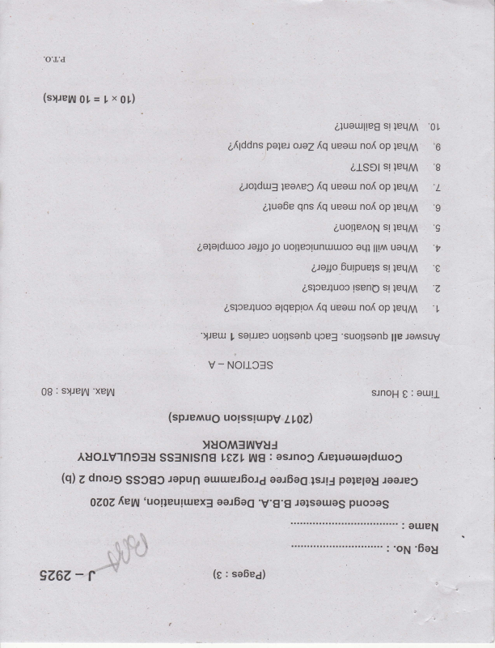

leqM s! Lluol.xlte8 '0t

}eLlM op no{ ueeur oJeZIq po}el a{lddns '6

s! alsct leqM '8

]eqM op no[ ueou {q qns alue6e 'g

leqM s! auotle^oN 'g

uallM lll^ orll uotleclunuuoc Jo Jol]o 6e1alduoc '?

0 leqM s! Oulpuels Uel1c

LslceJluoc sl tseno leqM 'z

}eqM op no{ ueou {q olqeplon aslcerluoc 'l

"Ueu qcef uorlsanb saueo I 'suollsenb suv Jol llp

Not133S - v

0B suey\l : 'xey\

oull : e sJnoH

uotsslutpv (sp.rernug LIOZ)

yuoMf ruvuJfteluaue;duog osrnog : 6E LtZ, SS3NISnA AUOIVI6CIU roareo polelag lslJ eal6o6 euruet6ol6 rspun SSOgg Zdno.rg @)  OZOZ puooas ralsauas 'V.g.g eel6og 'uot;euguex3 fieru

OUIEN :

i.::

l-"'i!.'|,'I

. ii} I' i.l !

r - 9267, sa6e6) (g:  ",,,;4.*t "'

'6eg op

=

r 9Z6Z-

Z

'ecueldecce e uleldx3 or.ll letluosso sluotuoto ]o

'92

ptlen

'slce4uoc pue olqepton qsrn6ullsl6 laq uool pton

'vz

lceJluoc

'tz

'slceJluoo uoal sluorueelbe qsrn6unsl6 loq pue

(s1.reyy9[=Zxg)

, 'suollsenb SuV JoA fiue xgs 'slJetu qce= uollsenb souJec 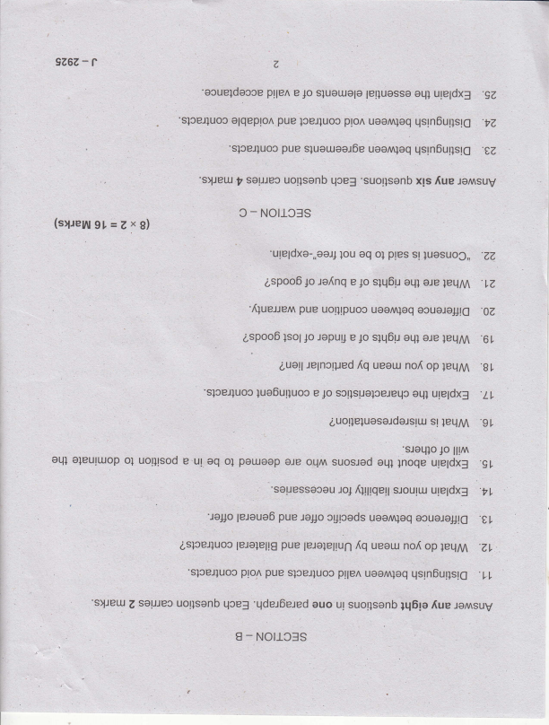

S Notl3f - 3

'ugeldxo-,,oaJ,lou st ples ol oq luosuoC,, -ZZ aspooolo ole oLl] s1q6lr 1o e .re[nq ]eLlM .lZ 'fiueJJen oouoloJ16 loq .OZ uool uotlrpuoc pue

leqM are aql s1q6u 1o e ropuu Jo lsol aspooo .6 L

auall op nof ueeur {q lelncrped ]eqM .g t

'sloeJluoc uleldx3 otll sctlsuoloeJeLp Jo e lue6ulluoc -Ll ]eqM sl euo[e]uose;delslr.r.r 'gt

'sJoLllo ll!^ Jo

suosred oll^ ore por.uoop ol oq ur e uotltsod ol oleuttuop oql rnoqr'rllr,jiiJ eq1 '91

;eleue6 'tl,

'Jo#o ocuoleJJt6 uoomloq cgrCeds JolJo pue

lerolellg aslceJluoo ^q op no{ ueau }eqM .ZL

pue

leJalellun

'slceJluoc uoo^ plle^ sloeJluoo qsln6urlsr6 loq .LL pue plol

'slJeu qce3 uollsanb solJJec Z auo

'qdet6e.red suv Joi {up 1q6le suotlsanb ul

NO|ICSS - I

r 9267,- 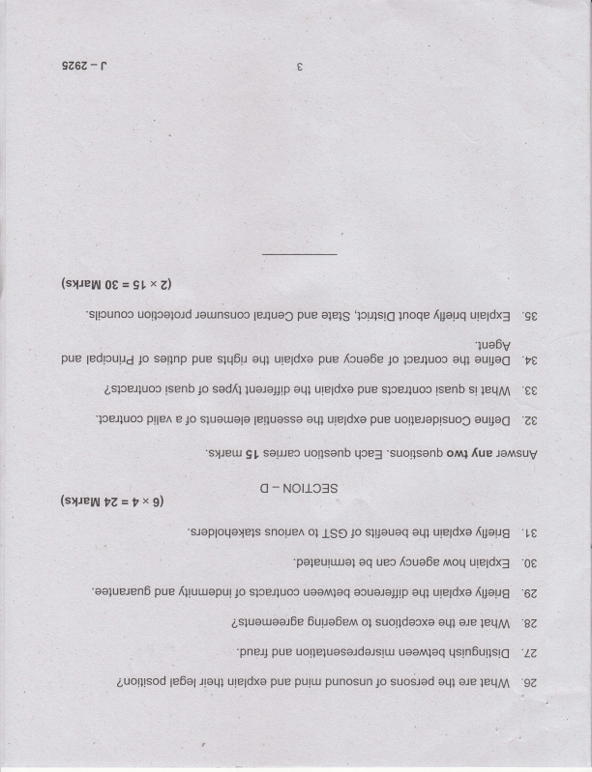

e

(sryeyy0t=9txZl

'slpunoc lounsuoc olels pue

uoqcelold

le4uoC 'lcpls'l6 ]noqe uteldx3 {peuq 'g0 lueOy

pue our}og ol-l} }ceJ}uoc 1o {cue6e pue ule;dxe oql slq6u pue soqnp 1o ;edrcui.r4

,t,

}eqM sl lsenb sloel}uoc pue uleldxo eq1 luolo;Jtp sed{} p lsenb aslceJluoo  e0

'lcelluoo ou1106 uotleJoptsuoC pue ureldxe oLll  'zt,

e pllen

?Z=?xg)

(s1.re111

lelluasso sluorlolo Io

gI 'slJetu qcef uorlsenb sorJJeo ornl 'suorlsenb SUV JoA fiue

Notl-css - o

oI snouen sJoploqa)els ule;dxe eLll sl4ouoq Jo ISe fpeug '10 'paleulruJal ure;dx3 anoq Icue0e uec '00

aq

'oalueJen6 {geug ule;dxe oql muaJoJ1p loq uao^ slceJluoc firuueputJo '67 pue

1eqry1 ere sLll suorldecxo o1 Ouue6enn asluouaoj6e ,g7 '

leq '/Z

'pnp4 qsrn6ullsl6

: uaan uo!]elueselde;sltu pue

punosun pulll pue ure;dxe 1e6elrletll auolllsod 'gZ

leqM ale aql suod1ed Jo

,i

J -2857

Second Semester B,A-/B.Sc./B.ComJBBA/BCA/BSWBMSIB.Voc. Degree Eiamination, May 2020

Career Rdlated First Degree Programme Under CBCSS

' Group 2(b)

, Language Course ll

1271.41EN211 ; WRITING AND PRESENTATION 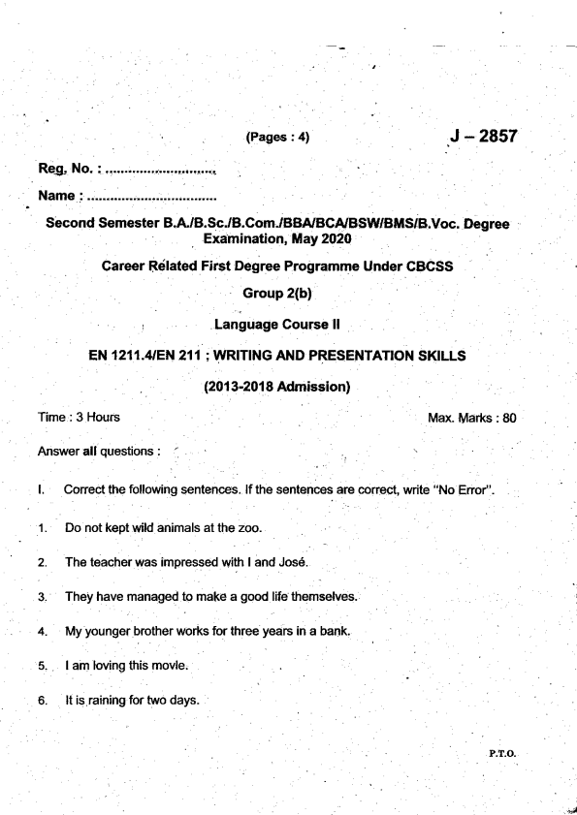

. (2013-2018 Adrnission)

t.

't.

2.

J.

4.

5.

6.

.

SKILLS

Max. Marks : 80 P.T_O-

It slipped the mind. 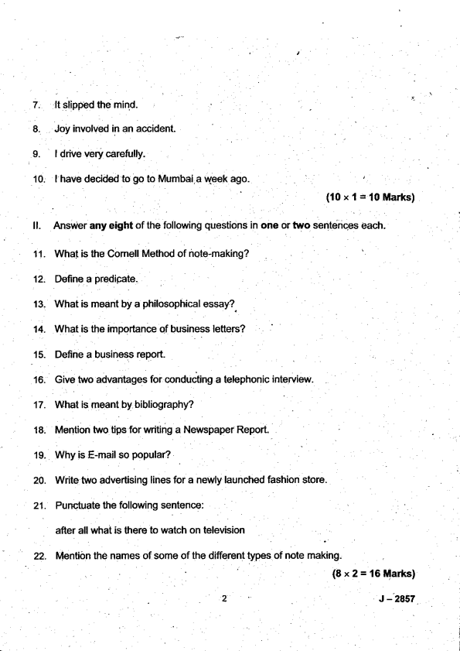

(10x1:'t0Marks)

ll. Answer any eight of the following questions in one or two sentences each. 11. What is ttre Comell Method of note-making?

12. Define a predipate.

13. What is meant by a philosophical essay?

14. What is the importance of business letters?

15. Define a business report.

16. Give two advantages for conducting a telephonic interview

17. What is meant by bibliography?

18. Mention two tips for writing a Newspaper Report.

19. why is E-mail so popular?

20. Write two advertising lines for a newly launched fashion store.

21. Punctuate the following sentence:

after all what is there to watch on television

' 22. Mention the names of some of the different types of note making. (8x2=16Marks)

J - 2457

lll. Answer any six directed.

23. Write a letter to the Librarian for reissuing your Library card.

Construct a dialogue on the following topic in about 80 words. 24.

You are at a Mobile Phone. You ask the shopkeeper about the phones.

latest mobile

25. Prepare a,report on Diseases'.

an awareness programme mnducted towards 'Lifestyle

26. Prepare a functional cuniculum vitae highlighting.your skills and experience. 27. What are the characteristic features of E-mails? 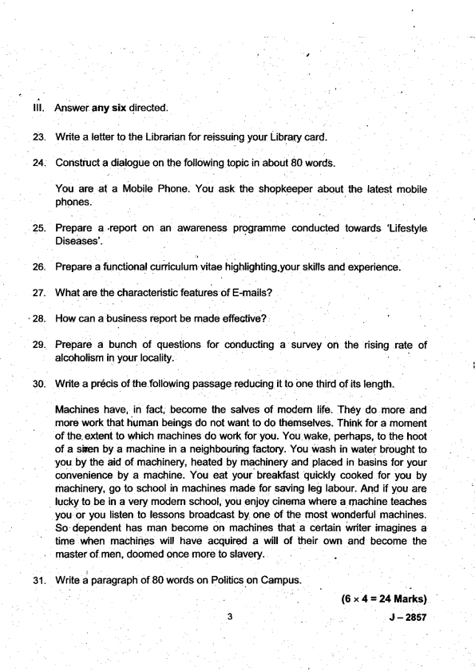

- 28. How can a business report be made effective?

29. Prepare a bunch of questions for conducting a survey on the rising rate of

30. Write a pr6cis of the following passage reducing it to one third of its length.

Machines have,.in fact, .become the salves of modem life. They do.more and . more work that human beings do not want to do themselves. Think for a moment of the. extent to which machines do work for you. You wake, perhaps, to the hoot of a sken by a machine in a neighbouring factory. You ivash in watei brought to you by the aid of machinery, heated by machinery and placed in basins for your convenience by a machine. You eat your breaKast quickly cooked for you by machinery, go to school in machines made for saving leg labour. And if you are lucky to be in a very modem school, you enjoy cinema where a machine teaches you or you listen to lessons broadcast by one of the most wonderful machines. So dependent has man bemme on machines that a certain w ter imagines a

' time when machines will have acquired a will of their own and become the master of men, doomed once more to slavery.

3l. Write a paragraph of 80 words on Politics.on Campus.

(6x4=24Marks)

,

3

J - 2AS7

Answer any two . of the following.

Write an essay on any one of the Jollowing in about two to three pages. 32.

(a) Reading as a habit.

(b) The drawbacks of social media.

(c) Universal Literacy.

33. Write a project report on any one of the following topics: (a) E-Leaming . .

(b) Rise of rural lndia,

(c) Decline in mortality.

u.

Create content for 15-20 slides on any one Presentation.

(a) The importance of communication. (b) The perils of smartphones.

(c) Youth and Social Media.

of the following Power Point

Write an essay elaborating the various methods of data collection. 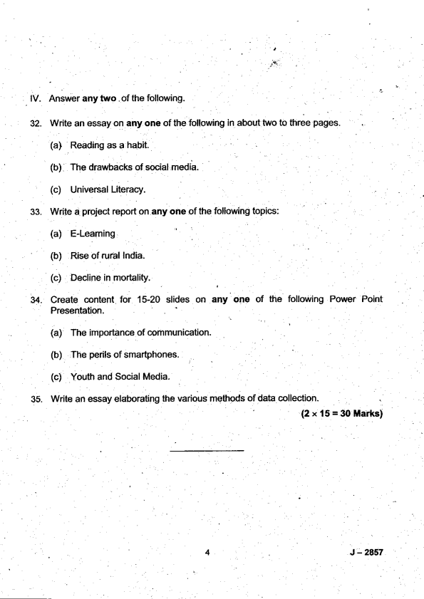

35.

' (2* 15=30 Marks)

J 4 - 2a57

(Pases:3) J -2922 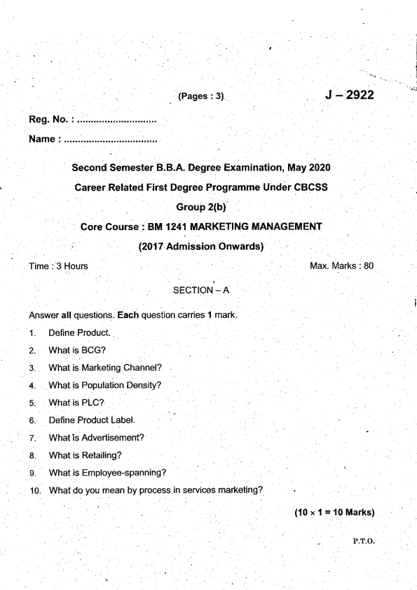

l

Name : .............................,,,..

,]

Second Semester B.B.A. Degree Examination, May 2O2O

Gareer Related First Degree Programme Under CBCSS

. Group 2(b)

Core Course i BM 1241 MARKETING MANAGEMENT

(2017 Admission Onwards)

I rme : :l Hours Max. Marks : 80 SECTION - A

Answer all questions. Each question carries 1 mark.

1. Derine Product..

2. What is BCG?

3. What is Marketing Channel?

4. What is Population Density?

5. What is PLC?

6. Define Product Label.

7. What is Advertisement?

8. What is Retailing?

9. What is Employee-spanning?

10. What do you mean by process in services marketing?

(10x1=10Marks)

_ P.T.O.

SECTION _ B, 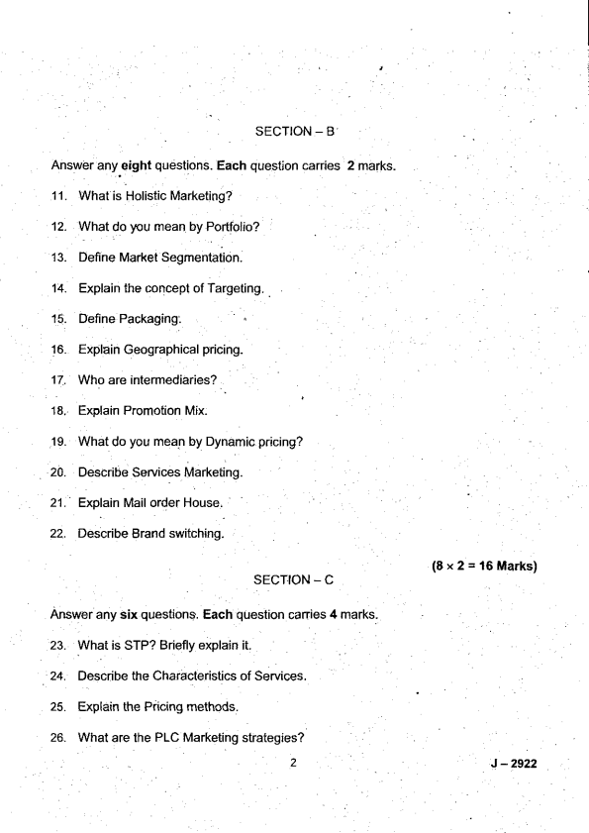

Answer any eight questions. Each question carries 1 1. What is Holistic Marketing?

12. What do )rou mean by Portfolio?

13. Define Market Segmentation

14. Explain the concept of Targeting. .

15. Define Packaging:

16. Explain Geographical pricinq.

17. Who are intermediaries?

18. Explain Promotion Mix.

19. What do you mean by Dynamic pricing? 20. Describe Services Marketing.

21. Explain Mail order House.

22. Describe Brand switching.

2 marks-

(8x2='16Marks)

J - 2922

(6x4=24Marks) 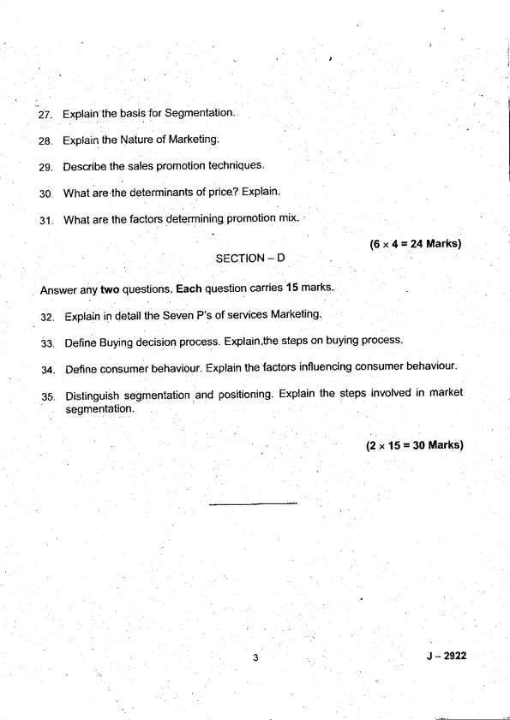

SECTION _ D

Answer any two questions. Each question carries 15 marks'

, 32. Explain in detail the Seven P's of seryices Marketing.

33. Define Buying decision process. Explain.the steps on buying process' 34. Define consumer behaviour. Explain the factors influencing consumer behaviour'

35. Distinguish segmentation .and positioning. Explain the steps involved in market segmentation.

(2 " 15 = 30 Marks)

J - 2922

Reg. No. i ..... *.... - . . . , . . . . . . . . . . . . Name

(Pages : 3)

J- 2923

Seccind Semester B,B.A Degree Examination, May 2020 Career Related First Degree Programme Under CBCSS Group 2(b)

Core Course : BM 1242 HUMAN RESOURCE MANAGEMENT (2017 Admission Onwafds)

Time : 3 Hours

t.

1.

2.

3.

4.

5.

6.

7.

9.

10.

SECTION - A 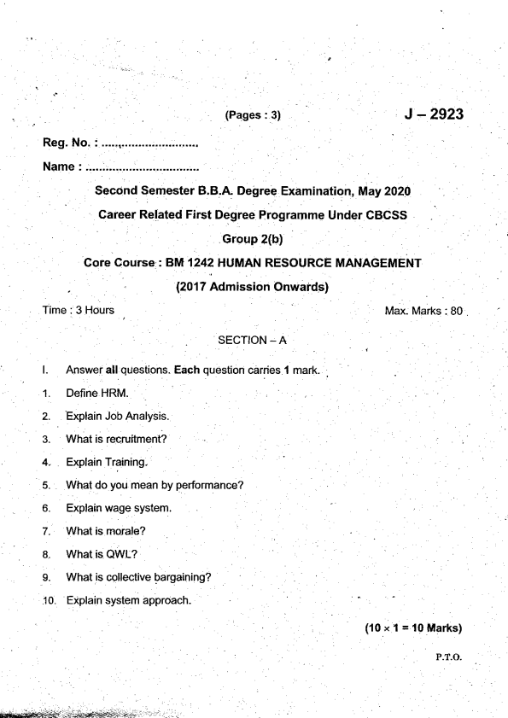

mark.

Max. Marks : 80

(10 x I = l0ltllarks) P-T-O-

(8x2=16Marks) J - 2923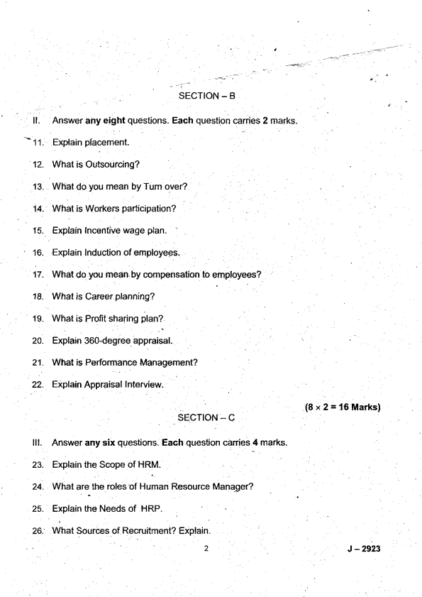

Briefly describe the Types of Management Development. Explain the Process of Performance Appraisal.

Discuss workers participation in Management.

Differentlate job descdption and Job Ddsign.

What are the types of interview'? Explain briefly.

31.

SECTION _ D

tv.

Answer any two questions. Each question carries 15 marks. .

(6x4=24Marks)

What do you.mean by Pertormance Appraisal? Explain its nature and objectives. 32. 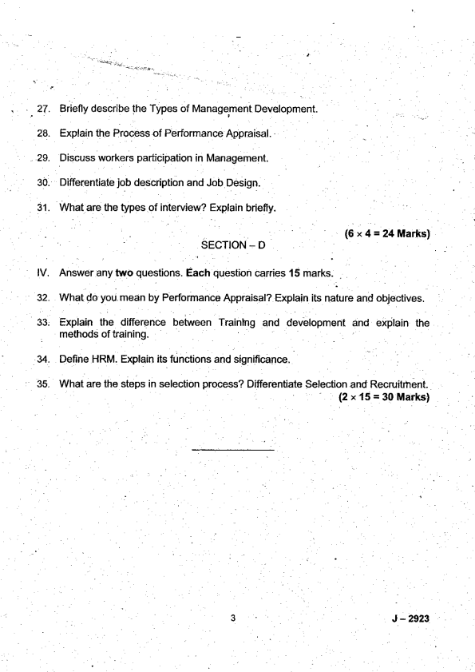

Explaan the difference between Trainlng and devebpment and explain the methods of training

u.

Derine HRM. Explain its functions and significance.

What are the steps in selection process? Differentiate Selection and Recruitrhent.

35_

(2 x 15 = 30 Marks)

J - 2923

(Pases:3) J-2924 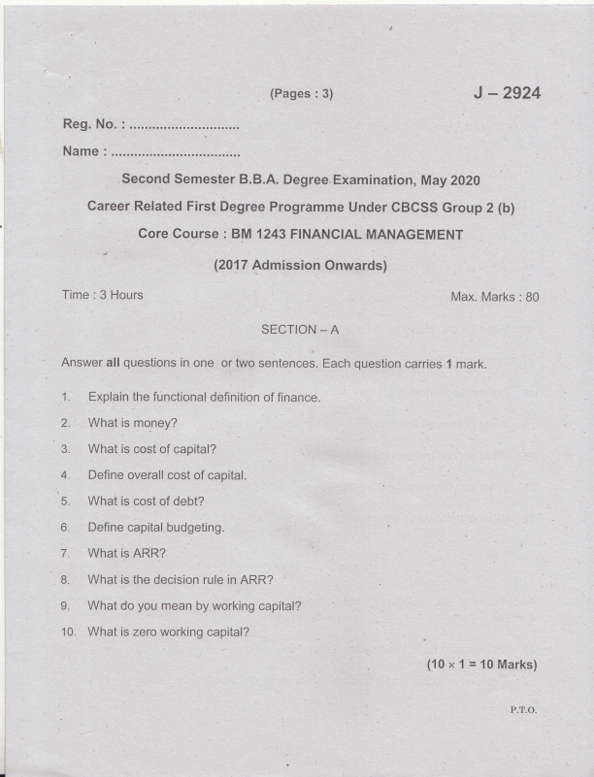

Reg. No. :

Name :

Second Semester B.B,A. Degree. Examination, May Z02O

career Related First Degree Progrimme Under cBCsS Group 2 (b)

'/

tl (2017 Admission Onwards)

Time : 3 Hours Max. Marks : B0 SECTION _ A

Ahswer: all questions in one or two sentences. Each question carries 1 mark. 1. Explain the functional definition of finance.

4. Define overall cost of capital.

:

5. What is cost of debt? l

1^ 7. What is ARR?

L What do you mean by working capital?

10. What is zero working capital?

(10 x 1 = 10 Marks)

P.T,O.

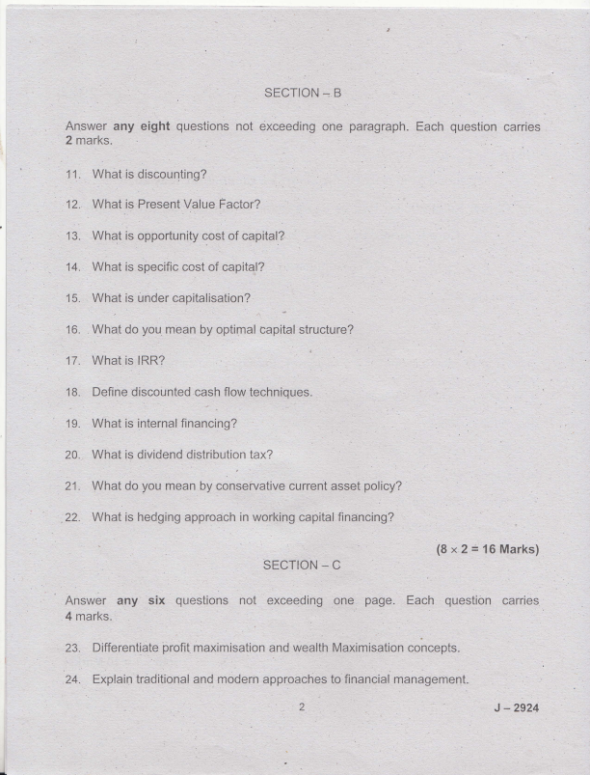

25. 

26. A ltd issued '10000 15% debentures of Rs. 100 each at a discount of Rs.S%.The debentures are irredeemable. Cost of issue is 2o/o and rate of tax 1s 5A%. Calculate the cost of capital before and after tax.

27. Explain the characteristics of optimum capital structure.

i

28. Explain the nature of capital budgeting.

30. Explain the assumptions of Walters model dividend theory.

31, Explain the motives for holding cash.

(6 x4=24Marks)

SECTION. D

Answer iny two questions not exceeding four pages. Each question carries 15 marks.

32. What do you mean by receivables? Explain the benefits associated with receivables and factors affecting the size of receivables:

Discuss different types of capital budgeting techniques.

, 'o' 35.

Explain the factois determines the dividend policy.

Explain the factors determine working capital.

(2 x 15 = 30 Marks)

J -2924

t

9- -Neithor my 'sentence). father not my brother are @ming for the. programme.

(Conect the

10. lcanrt , ' with this anymore! (Use tne-applopriate phrasal verb which means 'tolarate'. 

(10x1=l0Marks)

Answer any eight of the

. 11. Give the antonym of two of the.fonowing $d,tdq

(a) soff

'(a) How a pW thatpu

(b) Soa shame that he

13. Make sentences of your own with any two of the phrasal verbs :

(d) gave up

Fill in the blank with the conect Wh word :

{a) ---- is the best btlrger in this re.BtaUnant?

(b) I have not yet found fle girl

.i I J-.?521i

18. (a) {b)

Th€re are many types of rlsfres at the cold storage now.

19. (a) Ths dryrad,hg of the envir.onrnent u,ill leadlo our erd- (b) i,lany animals th€se days face axreflsbr,.

. lll. . Answer any slx of the follot ring qusstions : 

23. Match the pads in column A with that of collml I

(a) Practjoe the.-song we[ (D thal we may gain knowledge (b): Here comes n6ne other '(it) and a,lyricist.

(c) The boys care for neither , ( i) lest y6u forgret your lyncs.

' (d) Heis both a singer (iv) than the star singer!

(e) We.read (v) rnoney nor fame.

24. Fill.in the btanks with the conec{ oplion :

(a) I had asked.yog to 1--- immediately, hadn't l? (irrite menvrito to

. me)

(b) The inflation will- people badly. (atrect/efiec1)

(cl) He ms .:.---:- trom wort for. not doing his work well' (aid off/layed

25. Spot the 6nor, underline the' wrong phrase ard coned the sentences : I

(a) They do not stop lheir protest unless Uieir.pay is hiked.

(b) This shirt, so expensivei is too tight fpJ ms to w@r.

(c) She is absent orvning to her ill.

27. 

B: Yes

sure thal

29-

animal's, and

(b)

(c)

t

(d)

w.ortd, whicft

-'

(d) What do you rnean by halo? . 

- (aI

J -21;27

meaning to

(e) Why was he acc{sed of being a politician? (f) What does tuming'over in his rnind' mean?

(0 The Alpsare the Mountains in Europe. (g) This exam is.

e)demal examiner your'exam has anived--

(h)

The @!se is big :--------1- tor all of us to live in.

(i)

It was - evening when we reached the statioo (laternate) 0)

(k) He spoke (t)

his flrst bmk.

tired, u,e Uecided to lunch before going out. (being/to be)

(m)

My dog likes

cats. (to cias€/of chasing).

(n) ln spite of

(o) What do you plan

well, she was still tired; (having slepUsleeping)

her for her wedding? (to give/giving).

, (15x1=15ltarks)

GROUP B

Read the foflolr/ing passag€ and answer the questions below : 

34.

Qnce wfien I was six years old I saw a magnificent picture in a booft, called True Storie.s from l,lat re, about the pdmeval forel lt was a piciure of a boa consgictor in the ac{ of swallowing an animal. Here is a copy d the drawing. ln the book it said: 'Boa consMctors $/allow th€ir prey whole, without chewing it. Afler that they are not able to move, and they sleep through the six months that they need for digestion." I pondered deeply, [l€n, over the advenhrres of.the jungle. And affer sorne work with a colored pencil I succeeded in making my first drawing- My Drawing Number One. I shorved my masterpiecd to the grown-ups, anO aJked them whethbr the draw,ing. tbhFned them. But lh6y answered: iFrighten? Why should any onb ue fiighb@.by a hat?" i,ly drawing was not a pictw6 of a hat. It was a pk uIB of a boa Ss&ictor digegting an €lpphant But iince &e grown ups were not abb to un@r:tand.it, !made another drawing: I drew the inside of a Doa constriclo( so thd ttlB gronvn-ups could see it ctearty, They always need to have things explained.

l 

(a) What do You mean bY'magnifcent?

L (i). larsq (ii) exbeme! ireautitul maSrrifyns' (iv) tpnq of tle ahve :

(iiu magrrifying'

: , ' (b) What does 'pondered' nqan? ..

(i) to wander (iD like a Psd

(iii)lll, to Iuurll(qo{]ut thhk about (iv) uv, non€ rrvrr!ofthe vr {E aboven es

. (c) what is the meaning of 'disheartened?

fi) (benefited (ii) disptuitcd disptuit€d

' :' (iii) helped. ('9 su9pott€d .

(d) Which is the 'magnificent' picture mefll'tond?

I (e)l wtrat is a goa coGstrictor? :' '

'-,

I . (0 what was his first picfirre ofi

10- J.N'21

(i) to cany 

(lll) llcad

(m) ! rho is lhe nanator?

(n) . Give a suitable title for this passage. OR

(c)

(e)

(0

(s)

J - 2521

Time : 3 Hours

SECTION _ A

' J -2921 Max. Marks : 80

Answer.all questions in one ortwo sentences. Each question caries 1 mark. 1. What you mean by intemet? 

2. Expand HTML.

3. Expand C2C.

4. What is intemet shopping?

5 What is flowchart?

6. What is digital signaiure?

7. What is E business?

. .8- Expand lSP.

P.T,O.

9. What is firewall?' 

10. What you mean by cybercrimes?

_ (10 x 1 = Io:Marks) .

SECTION - B

Answer any eight questions not exceeding one paragraph. Each question canies 2 marks.

'l 1. What is search engine optimisation?

'12. Differentiate website and webpage

13. Define VVWW.

14. Deline E-Commerce.

15. Define encryption.

16. Who are certificate authorities?

17. ' Explain cheque transaction protocol used in E-commerce.

18. Define electronic payment system.

19. Deline e- business application

20. Define decryption of data.

21. What you mean by e-cash?

22. Write any t\ o examples of antivirus softwares.

(8x2=16Marks)

2 J -2921

SECTION - C 

Answer any six guestions not exceeding one paragraph. Each questions canies 4 marks.

23. Explain the advantages of E-Commerce.

24. Explain the operations of E-Commerce.

25. Briefly explain lhe advantages of.B2B.

26. Explain the various types of advertising on the intemet.

27. Describe the benefits of electrdnic payment sysiem.

28. Explain the behefits of firewall,

29. Explain the advantages of website. l

30.. Describe the advantages of debit card. '

31. Explain the public policy issues in e-commerce.

(6x4=24Marks)

SECTION - D

Answer any two questions not exceeding four pages. Each question canies 15 marks.

(2 x 15 = 30 Marks)

J - 2921